**Computer Sci Electrical Engr 5590 0005**

**Big Data Programming**

**Project Title**

**Analysis on Covid-19 Vaccination**

**Team Members:**

Prakhya Srungarapu - [psrv7@mail.umkc.edu](mailto:psrv7@mail.umkc.edu)

Sai Saranya Vipparla - [svv7x@mail.umkc.edu](mailto:svv7x@mail.umkc.edu)

Vamshi Krishna Routhu - [nrqnh@mail.umkc.edu](mailto:nrqnh@mail.umkc.edu)

Shiva Kumar Murarishetti – [smpf4@mail.umkc.edu](mailto:smpf4@mail.umkc.edu)

**Introduction :**

Analyze the vaccination data with charts, news, important dates, and many more is always hard which leads to inaccuracy in analysis and investment in particular stock. This project helps to analyze the Covid-19 vaccination data and the data is collected from twitter data, implemented using Hadoop ecosystem. It collects the twitter data associated with the vaccination details and analyze/predict the vaccination movement.

**Background :**

There are many articles which tells about the Covid-19 analysis using Hadoop Technologies. But there is no depth analysis of data. Only few articles talked about twitter data and no proper implementation is done.

**Goals & Objectives :**

The main goal of this project is to analyze the Covid-19 Vaccination data with the help of twitter data and also other public data using Hadoop ecosystem. This system collects the twitter data associated with the Covid vaccination details based on the user tweets and extract the trend from the analysis.

**Motivation :**

We have tried hard to analyze the Covid data from the main source twitter and other public sources, but we failed many times. We always have an extremely hard time analyzing that huge amount of data and coming to a decision based on the analysis. And analyzing that huge data takes a lot of time and got to concentrate on various works too. So, to do this task for us we need some sort of Big data tools to analyze and give us filtered results. Not only that as big data tools analyze data extremely fast, we can make decisions quicker than we do. We can also avoid human error using these tools. Moreover, As large number of people are in need of vaccination, we need to have proper data insight so that vaccines can be distributed in an effective and fastest way.

**Significance :**

* How does their country economy get impacted due to vaccination?
* How the distribution should be done?
* Big data tools help to process huge amounts of data efficiently.
* This would be helpful for the governments and the common people to make their decision towards the vaccination.

**Objectives :**

To analyze covid-19 vaccine data, we will be collecting the twitter data using python script and processing the data. Different tools in Hadoop ecosystem will be used to analyze the data and help in predicting the movement of the Vaccination.

**Features :**

The main feature of this project is twitter data extraction, analysis on the extracted data. Using HDFS to store the data. Apache spark to process the data and Hive for querying the data. A visualization tool for showing out the results.

**Dataset Twitter Dataset:**

https://drive.google.com/file/d/1HXqu3l37xNqC82IXX2xzAraJlxcZ-ePz/view?usp=sharing

## **Architecture:**

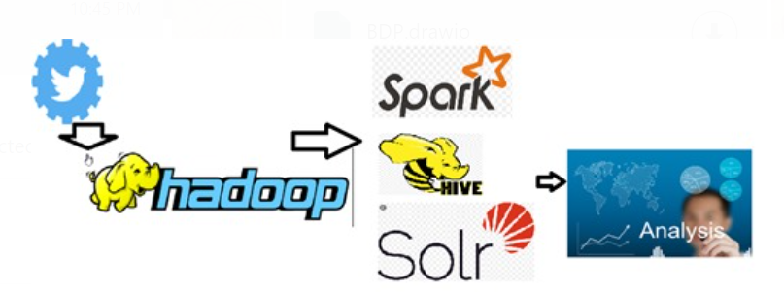

## Workflow:

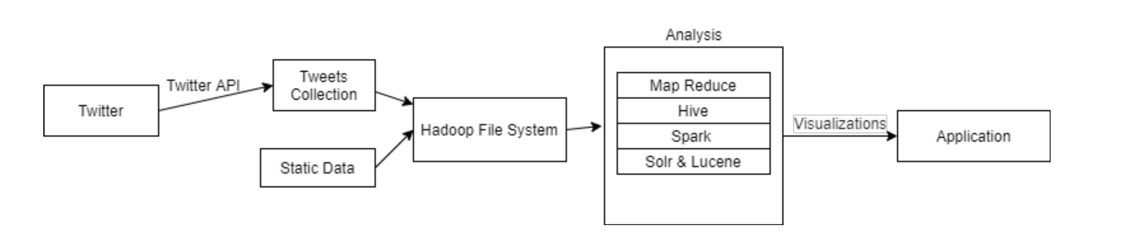

Analysis: (Data)

Twitter is one of the best data sources as it contains huge public opinions. Various number of users/ companies tweets the information regarding many things. This dataset is about Covid 19 vaccine’s distribution and the sentiment of people of the former. Hence, we extracted all the tweets related to the it. Since, our project is to analyze the previous data and predict/analyze the data we are considering the tweets.

The dataset looks like below

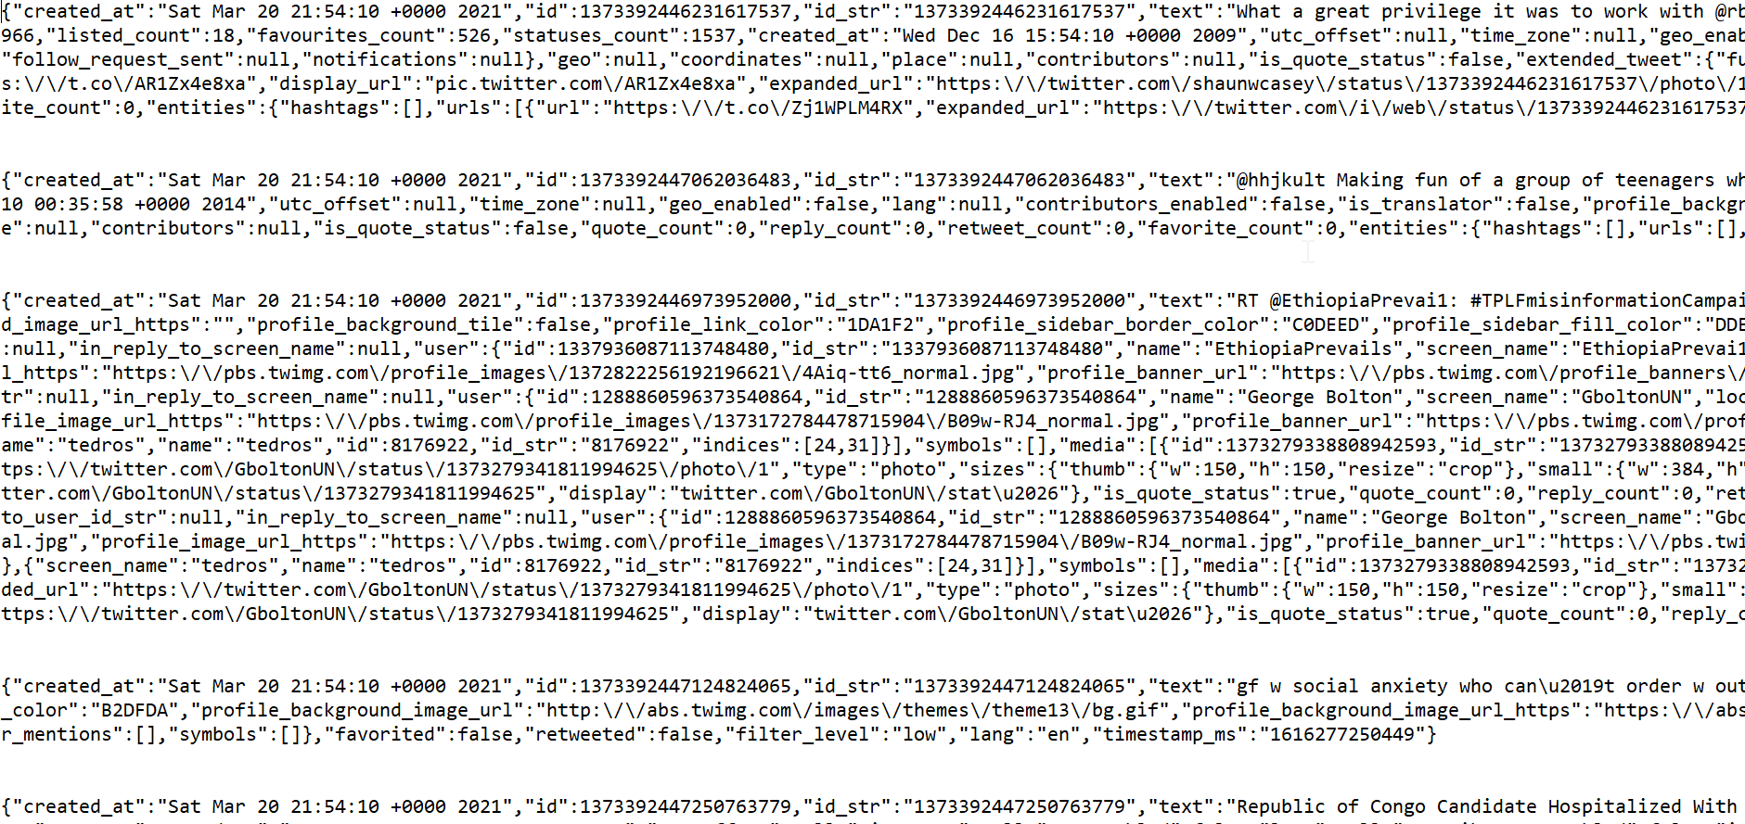

**Features :**

The features of this project would be analysis on the twitter data, public data sets available. Storing the data in the HDFS, Processing data using Spark, Querying using Hive Query language. Generating visualizations using matplotlib, NumPy, Pandas, Seaborn and Tableau. Showing the visualizations on the web application. Deploying the application in the docker.

**Implementation:**

* **Extracting Tweets:**

We use Tweepy to extract the tweets. Tweepy is a python package that smoothly accesses twitter’s endpoints which are available for developers. It also allows us to handle various implementation details like- Rate limits, Data encoding and decoding, HTTP requests.

Twitter Developer account access

Sign Up for Twitter.com

Raise a request for Developer Access for developer.twitter.com with Student Email Address(@mail.umkc.edu)

Create a New Application

Goto My Applications

Create a New Application

Fill the required Details

create/generate the token

These credentials can be used to download tweets using Tweepy.

The below code is used to initialize Tweepy and import the tweets using python.

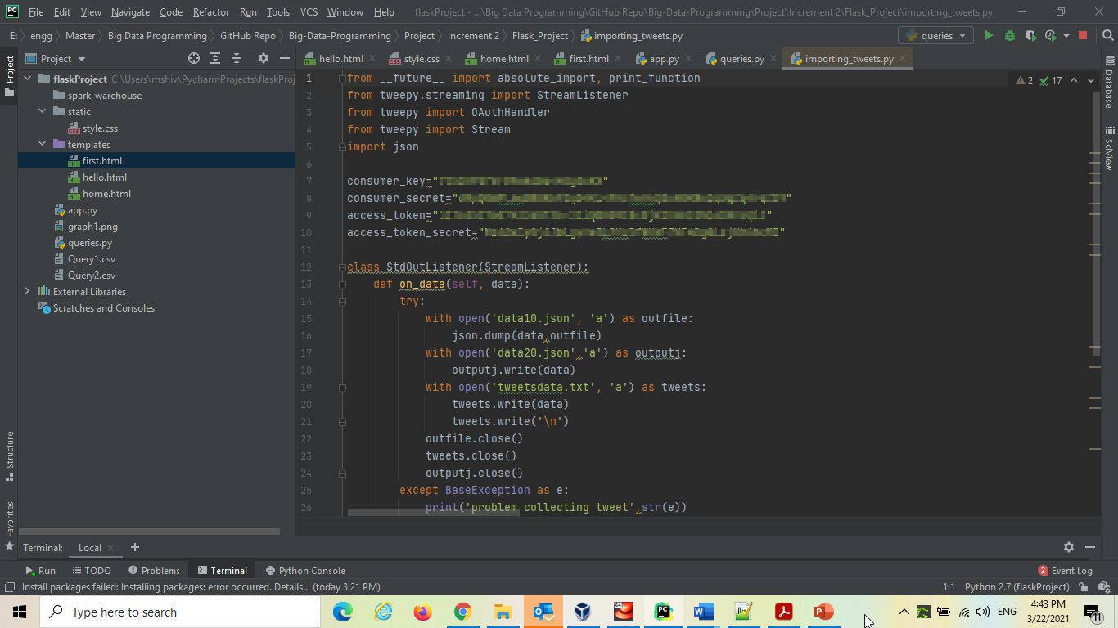

All the tweets extracted by Tweepy will be stored in the file ‘tweetsdata.txt’.

All the tweets extracted by Tweepy will be stored in the file ‘tweetsdata.txt’.

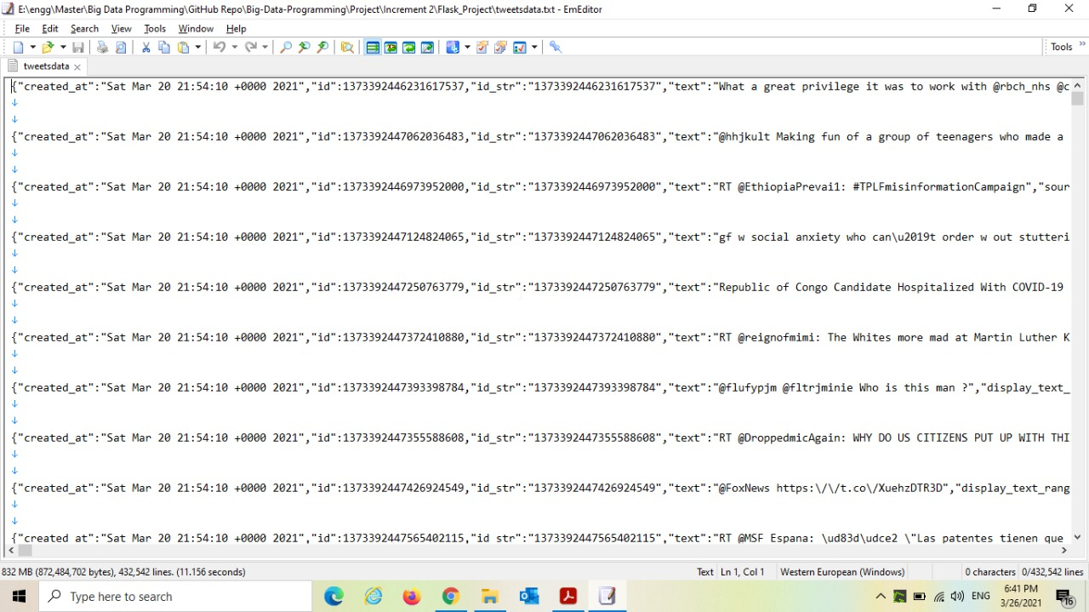

* **Creating and Storing data into HDFS:**

A new input folder is created in Hadoop using the following code.



Now our files are moved into HDFS.

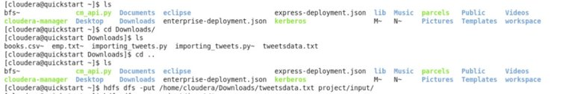

Data can be viewed in Hue

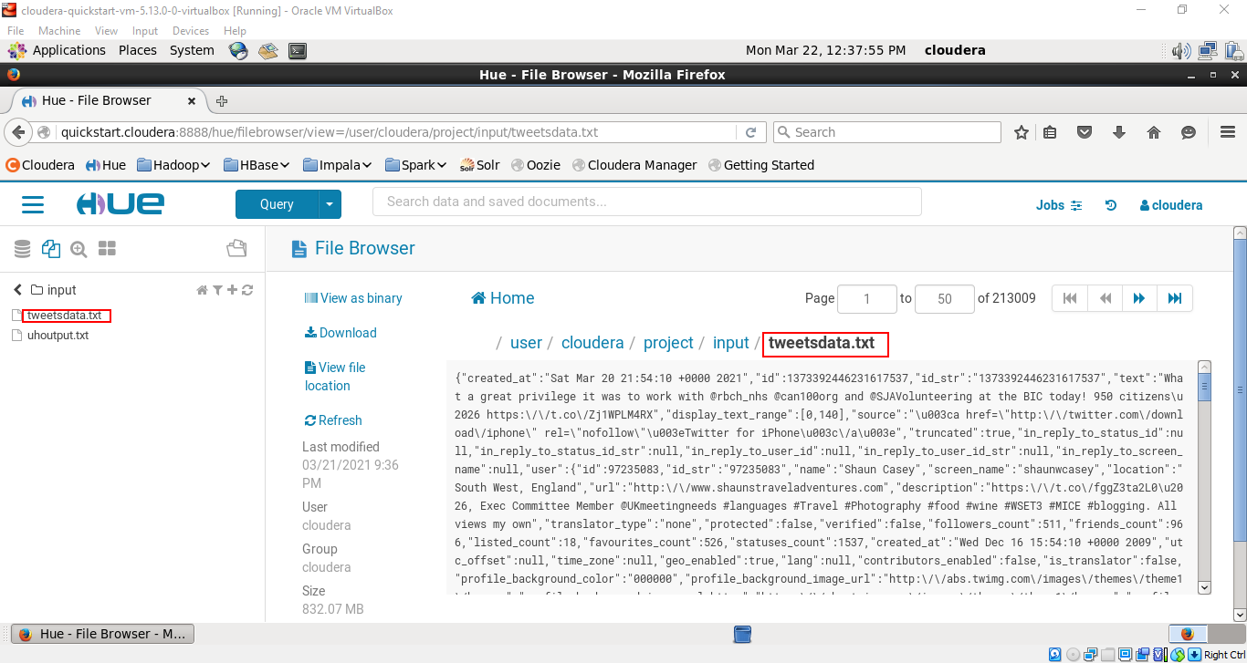

Extract Hashtags from the downloaded data

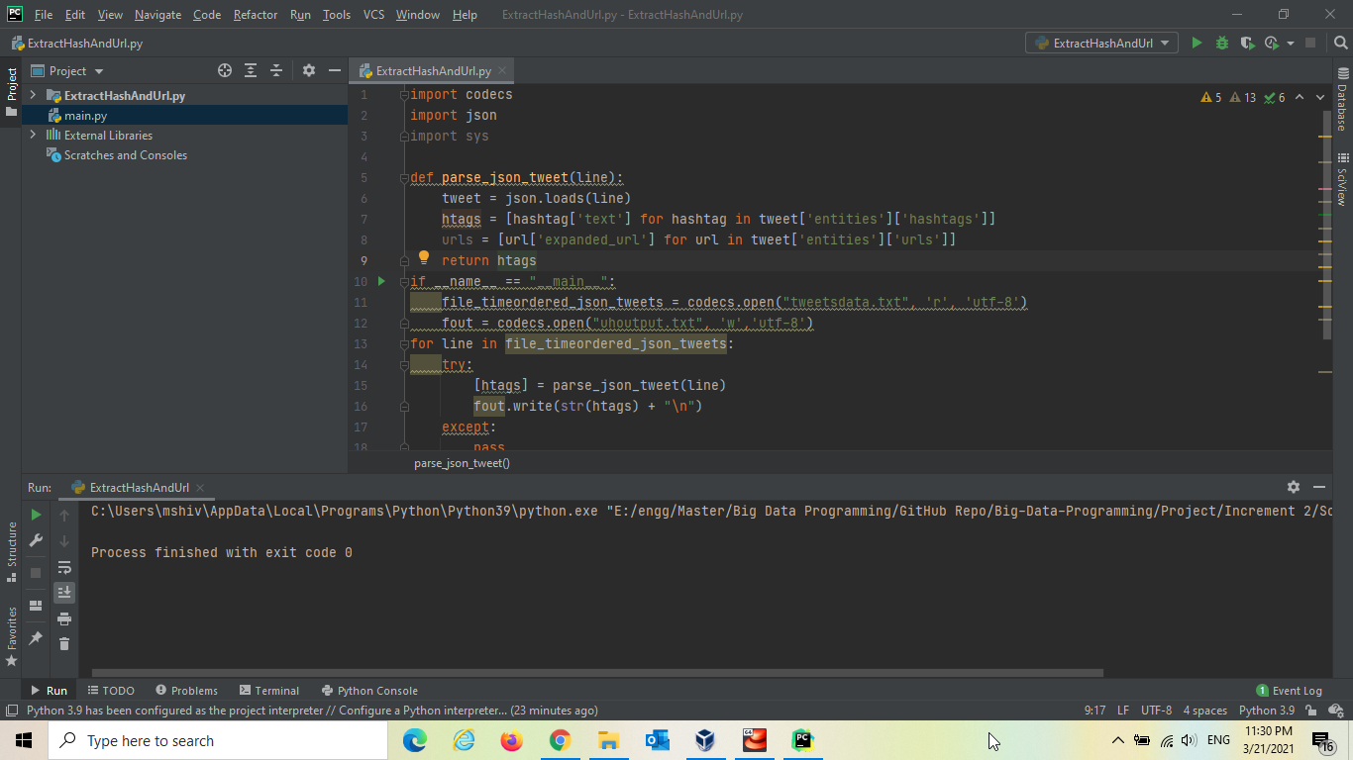

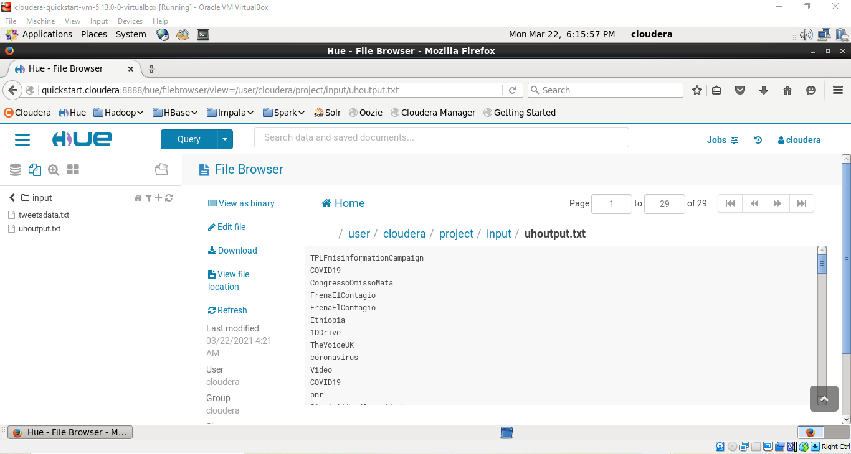

Performing Word Count using Map Reduce Perform

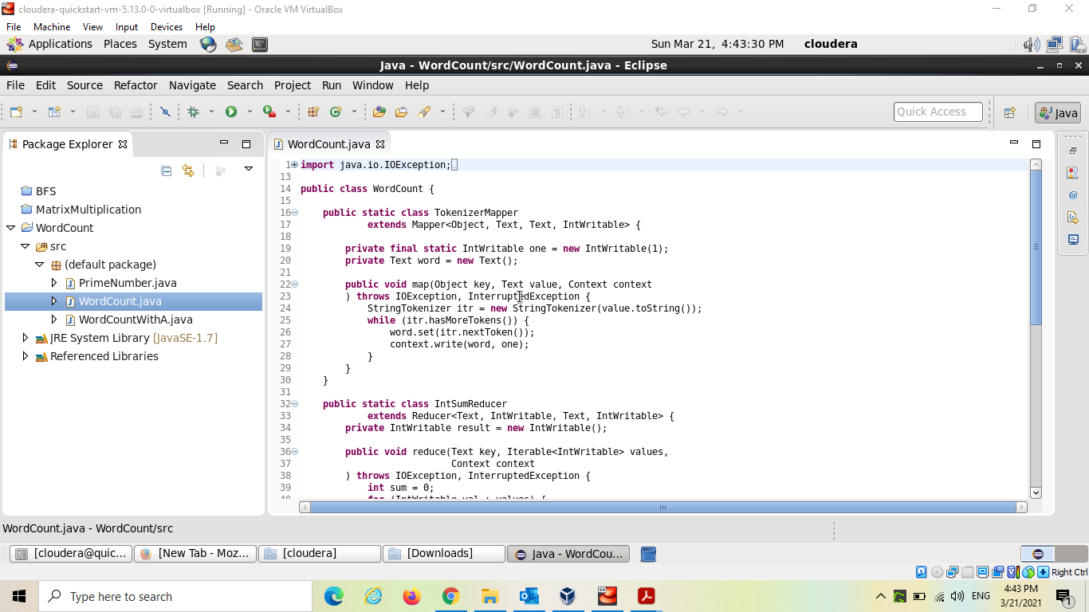

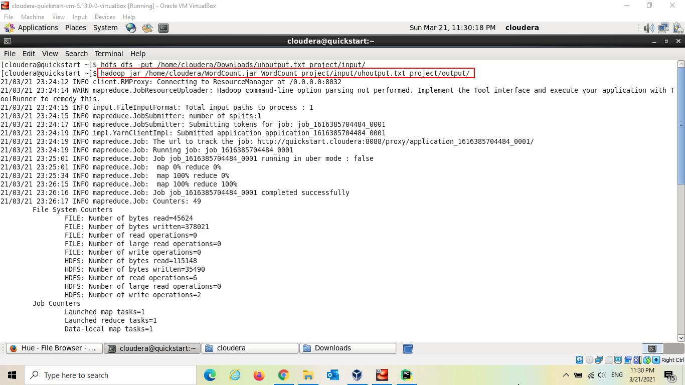

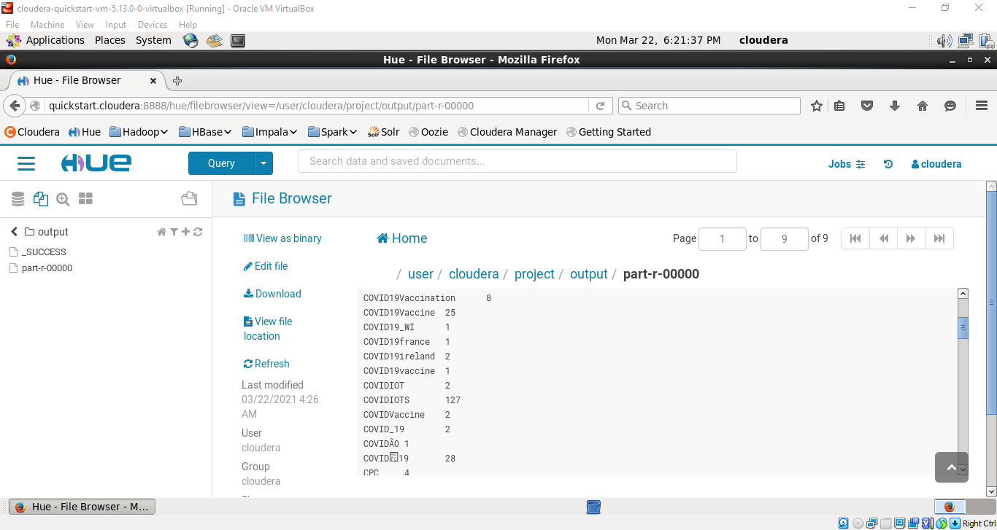

* **Operations in Spark**

Let’s calculate Word Count using Map Reduce in Spark by scala

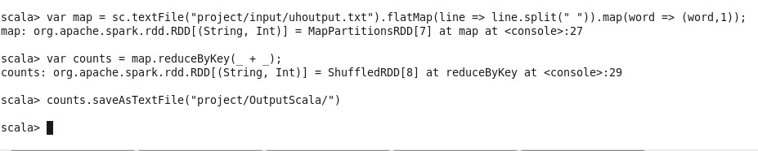

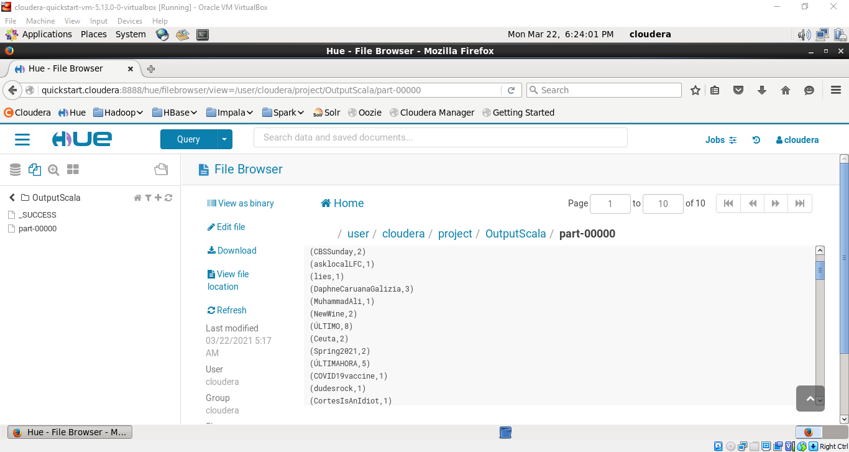

Selecting 5 counties from the dataframe

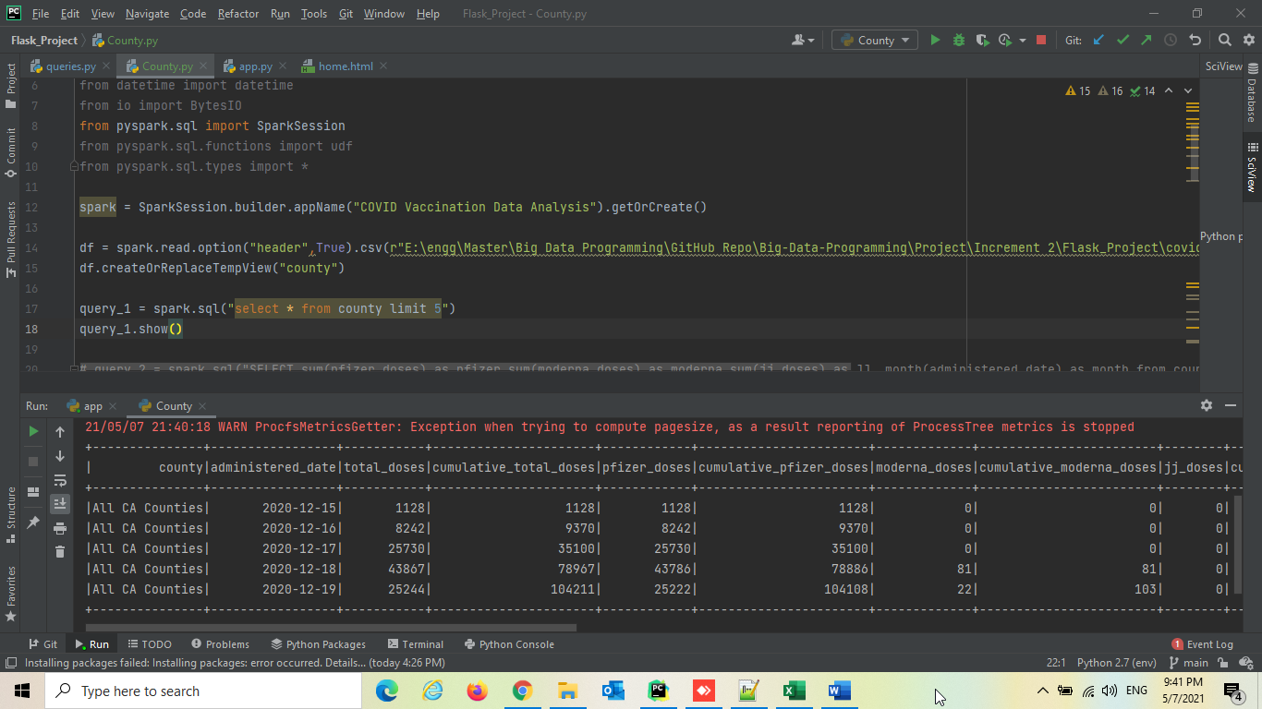

Sum of overall Pfizer, moderna, J&J distribution calculated monthly

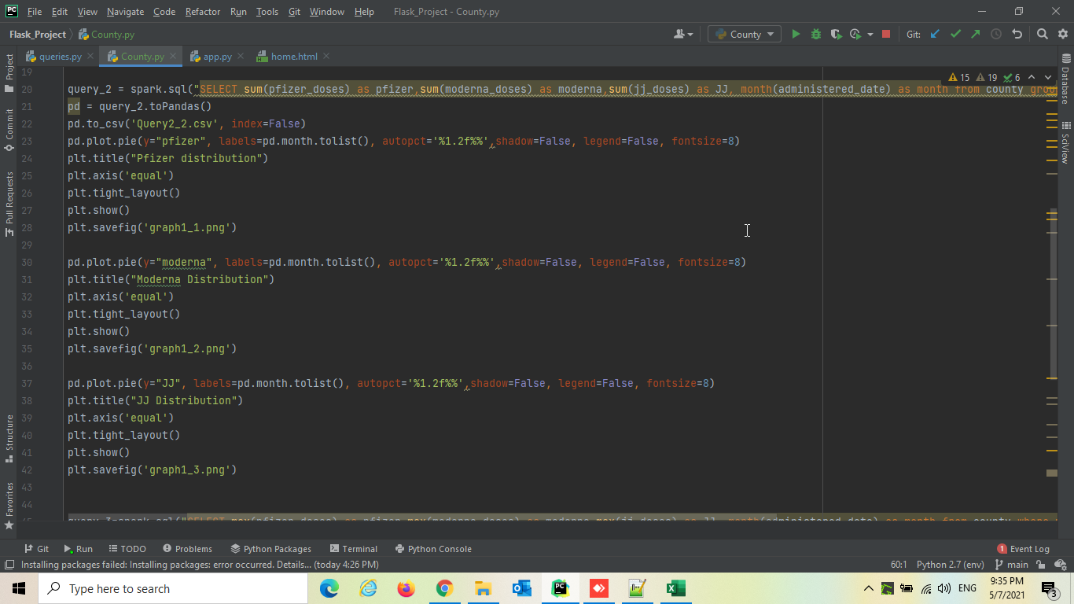

Sum of overall Pfizer distribution calculated monthly

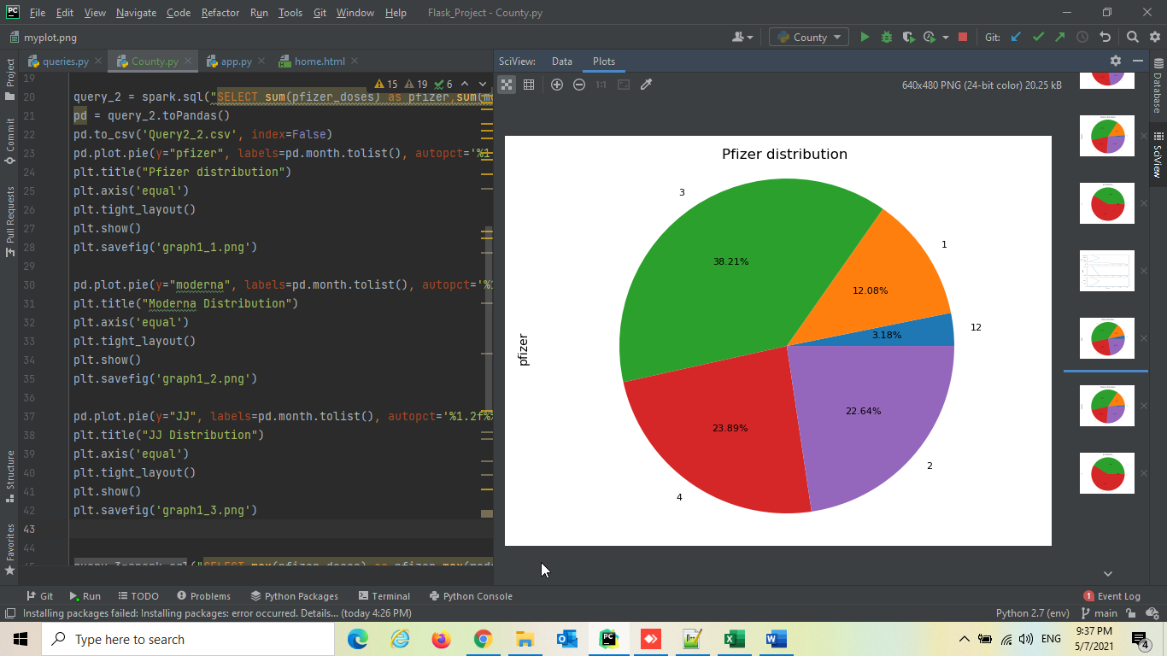

Sum of overall moderna distribution calculated monthly

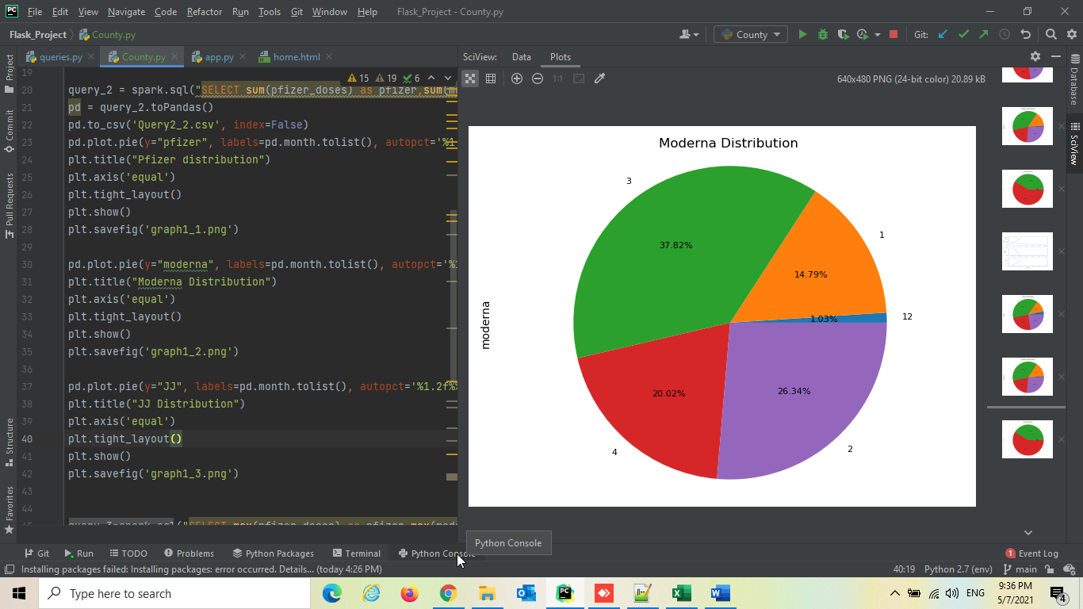

Sum of overall J&J distribution calculated monthly

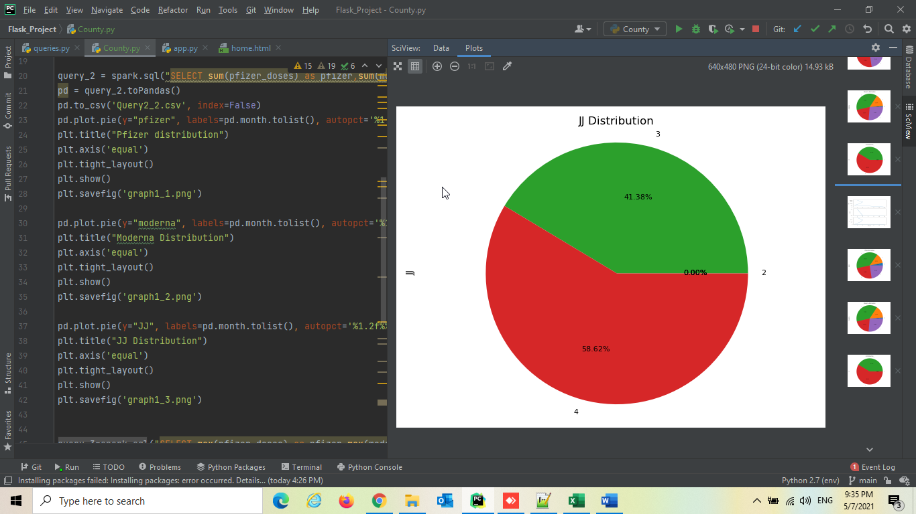

Maximum monthly doses distributed of Pfizer, Moderna, J&J

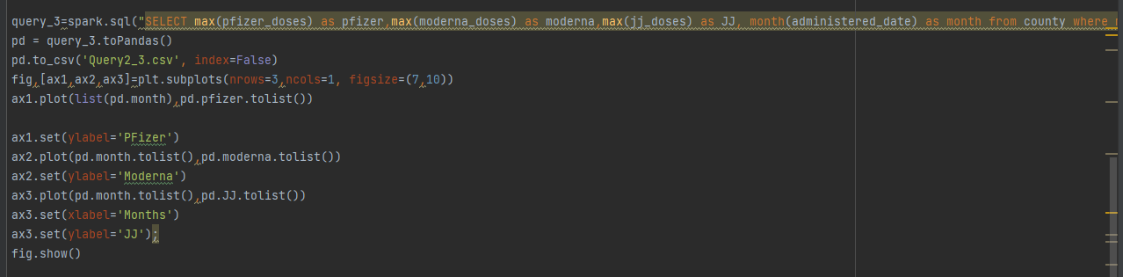

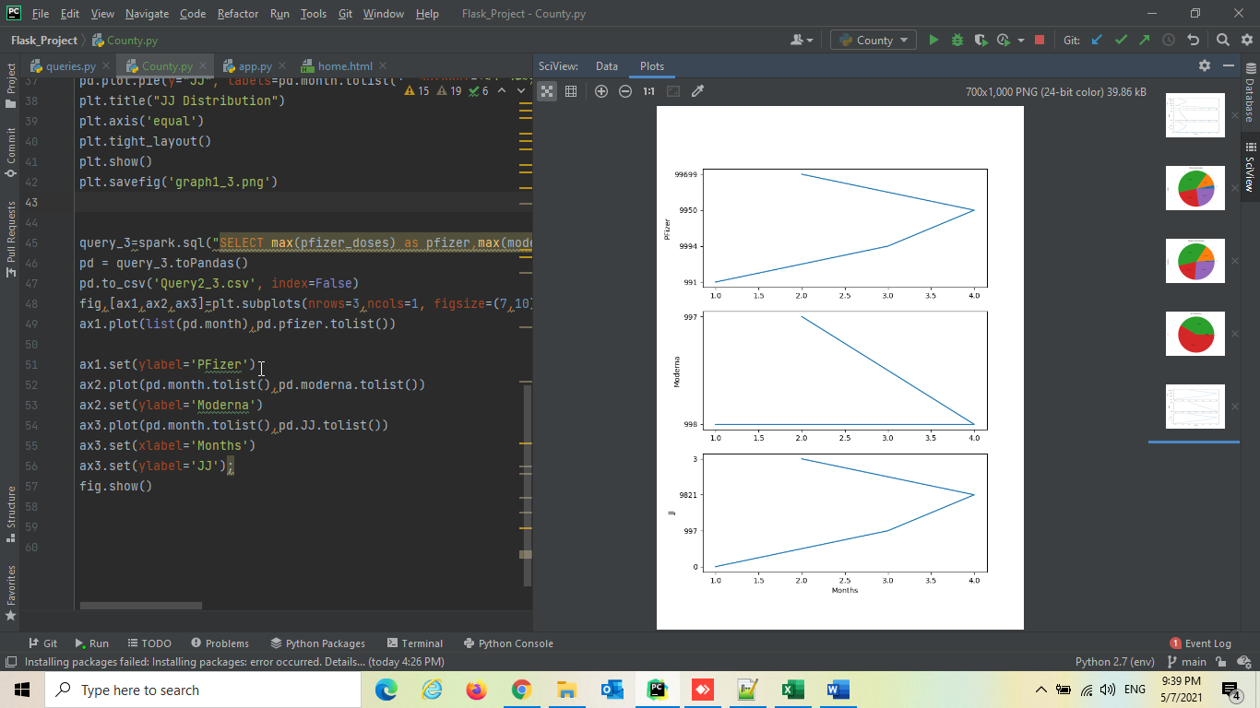

Number of fully vaccinated people based on each County

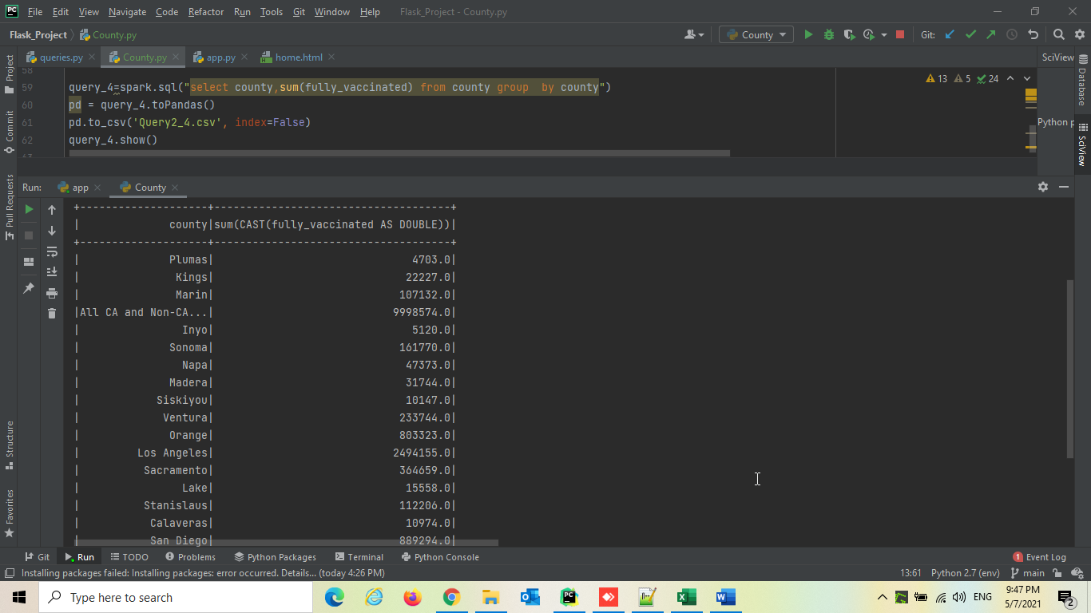

Number of partially vaccinated people based on County

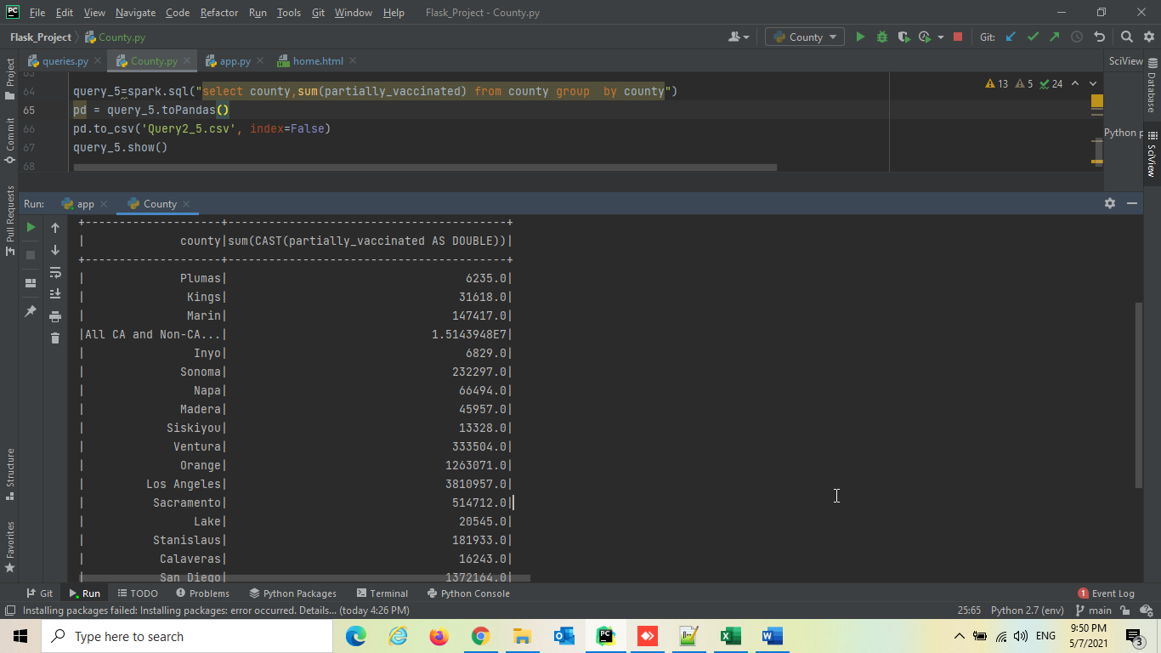

Top 5 Partially vaccinated and fully vaccinated people based on County and month

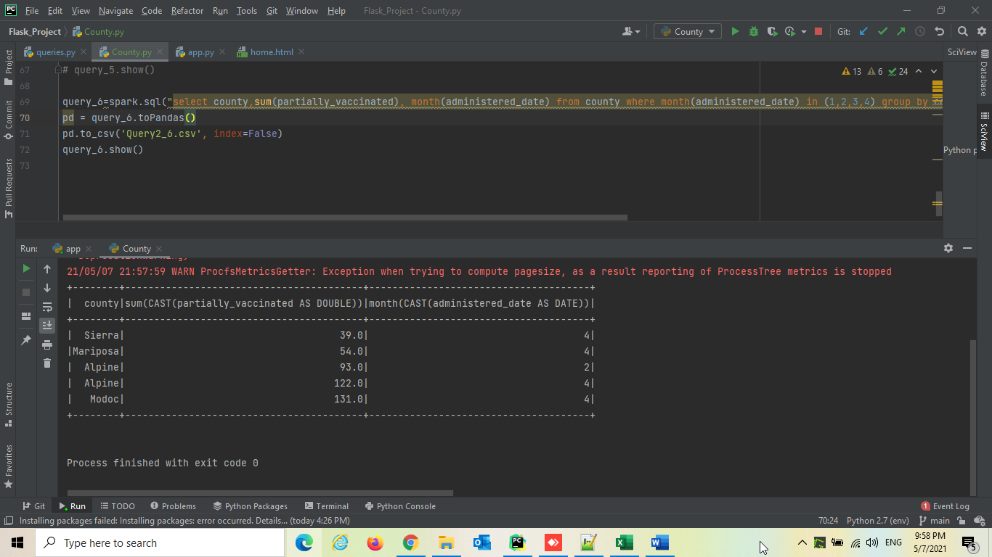

Total Number of tweets processed in Spark

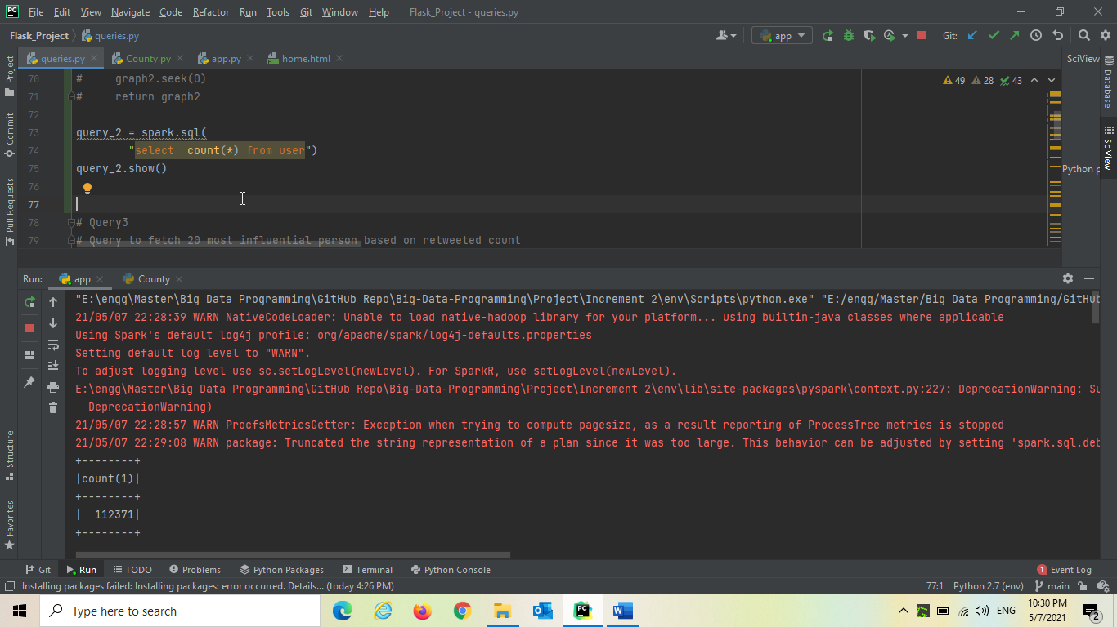

Trending Hashtags

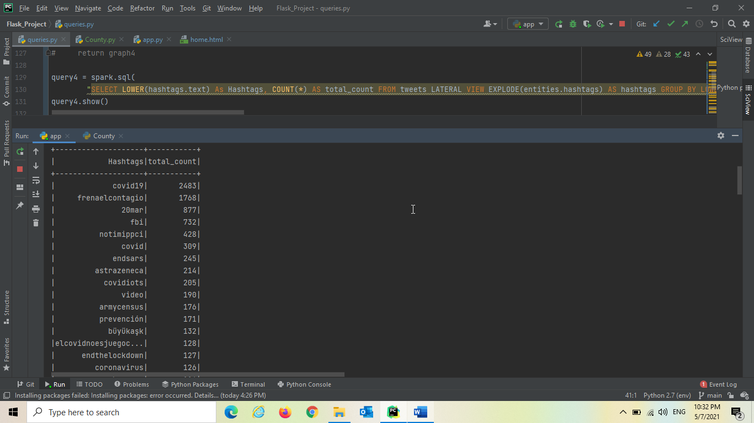

description from user where it has keyword vaccine

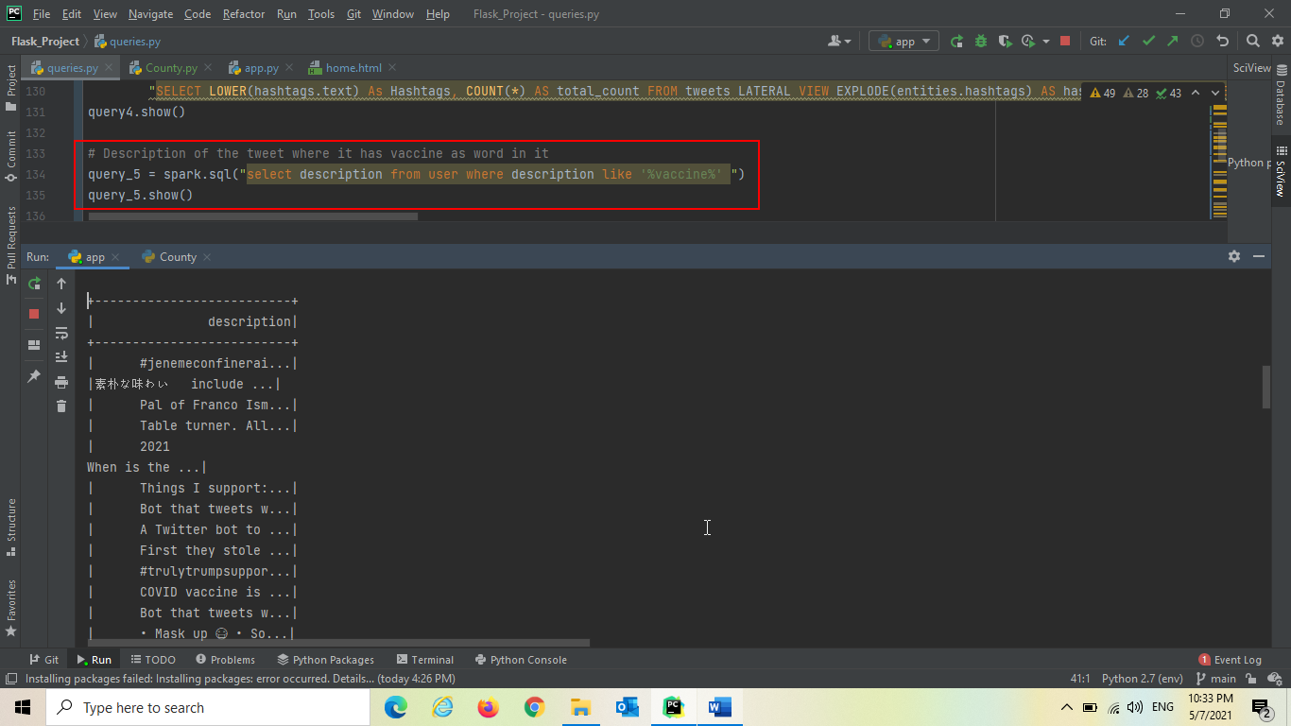

Trends on Number of friends

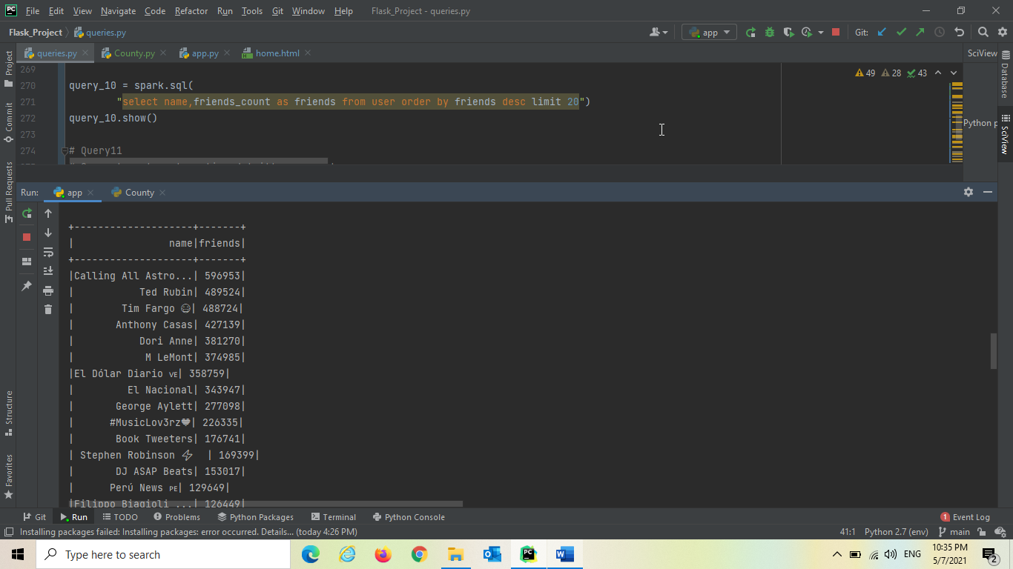

Most Mentioned Twitter Accounts

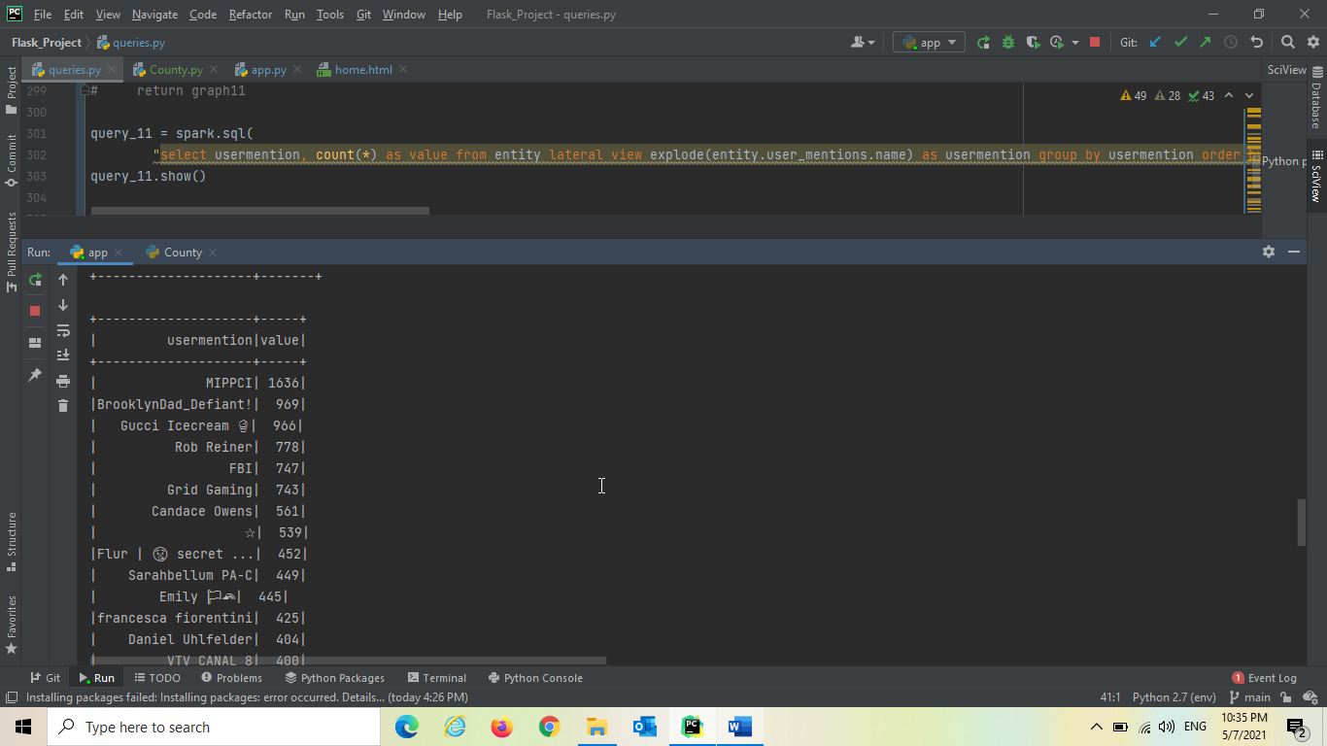

Accounts With More Followers Count Based on Location

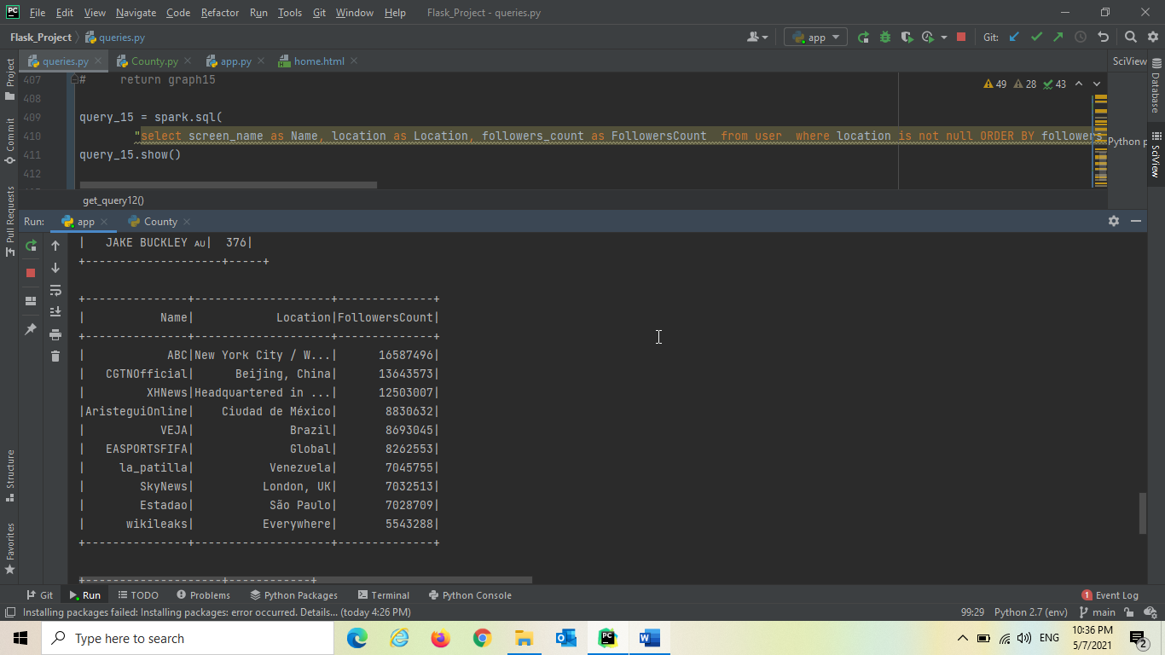

Top Retweeted Tweets(Tweet in english language)

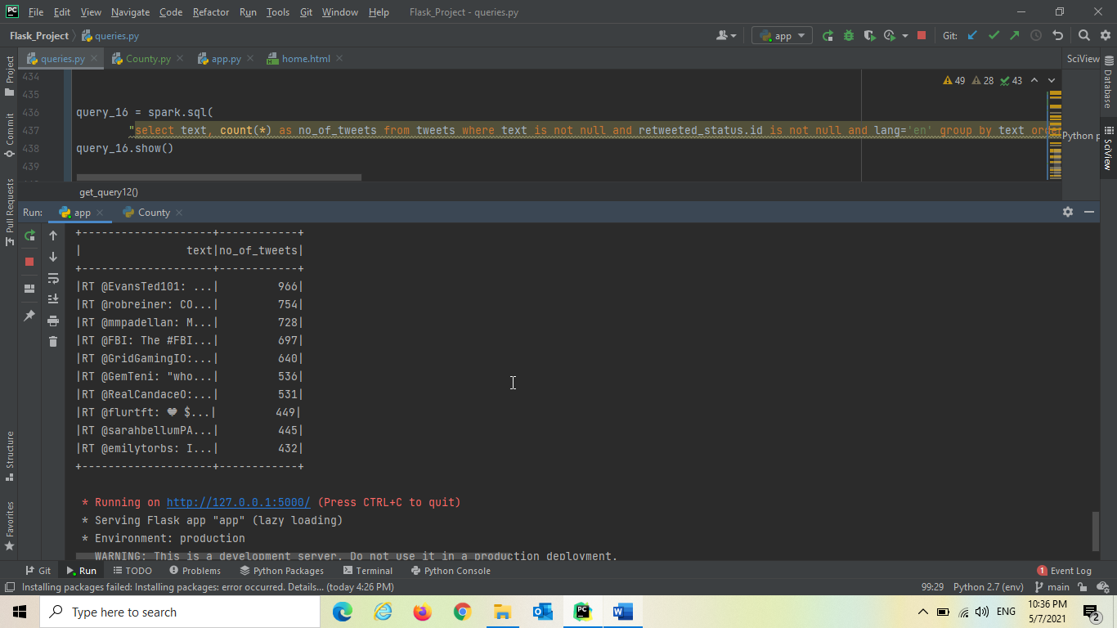

Home page of our Flask web application

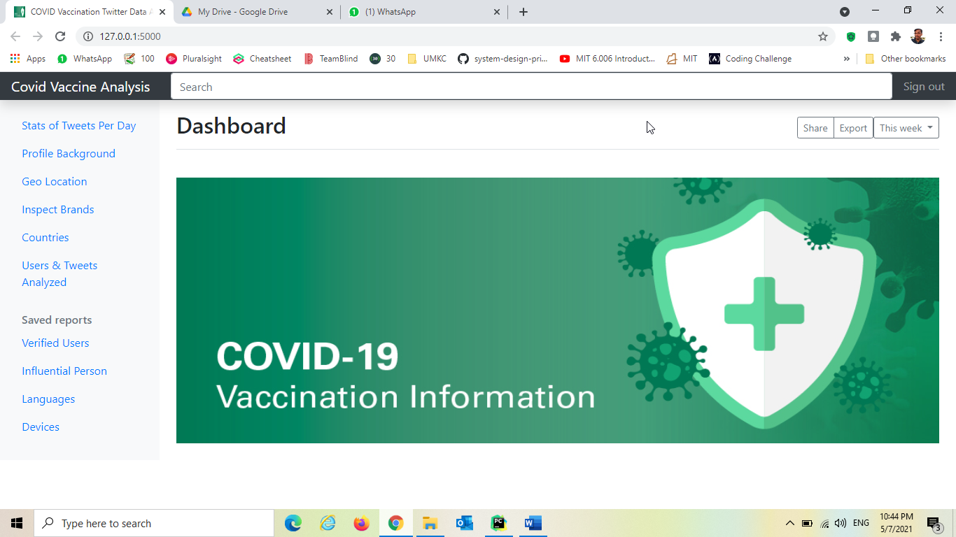

When user clicks on Verified Users, it goes and triggers the query “Followers Count of verified Users” and dynamically generates visualization and returned to the application

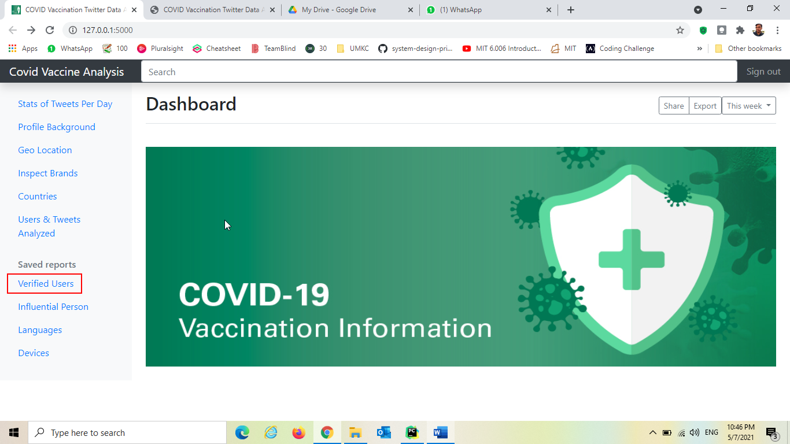

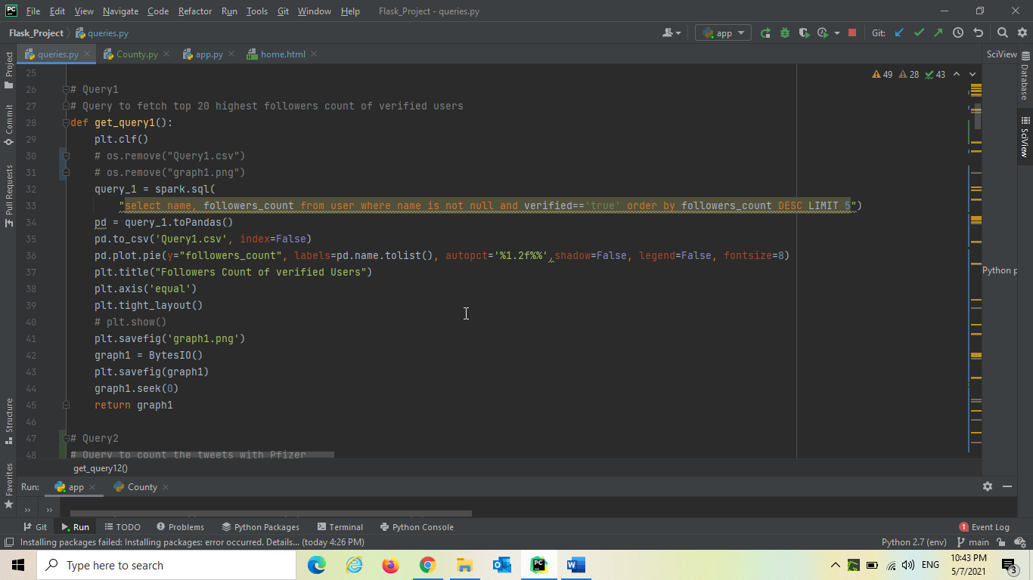

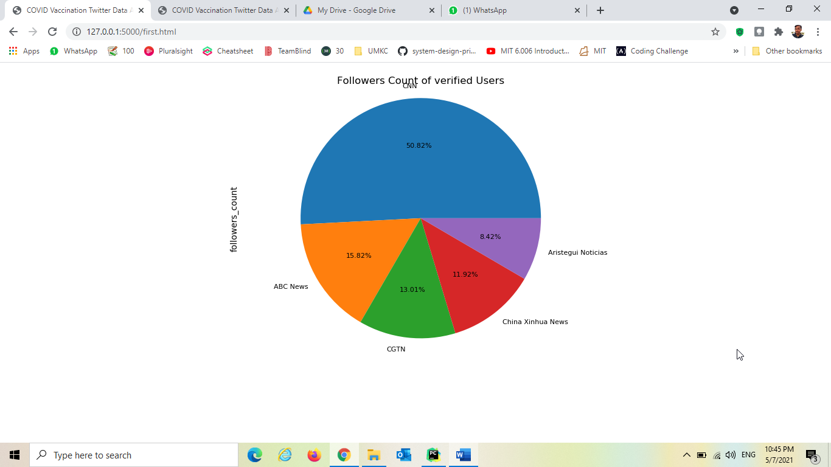

When user clicks on influential person, it goes and triggers the query “Most Influential Person Based on Retweet” and dynamically generates visualization and returned to the application

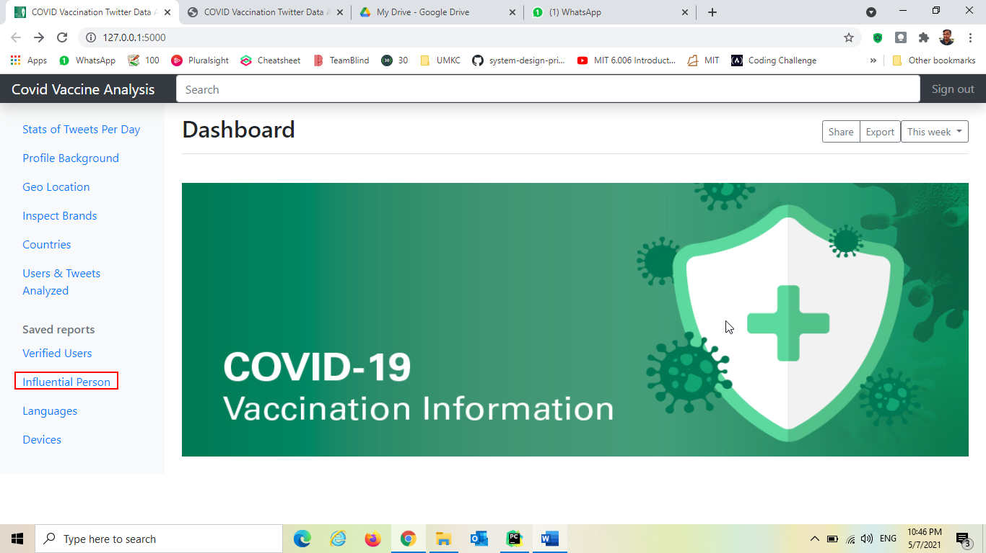

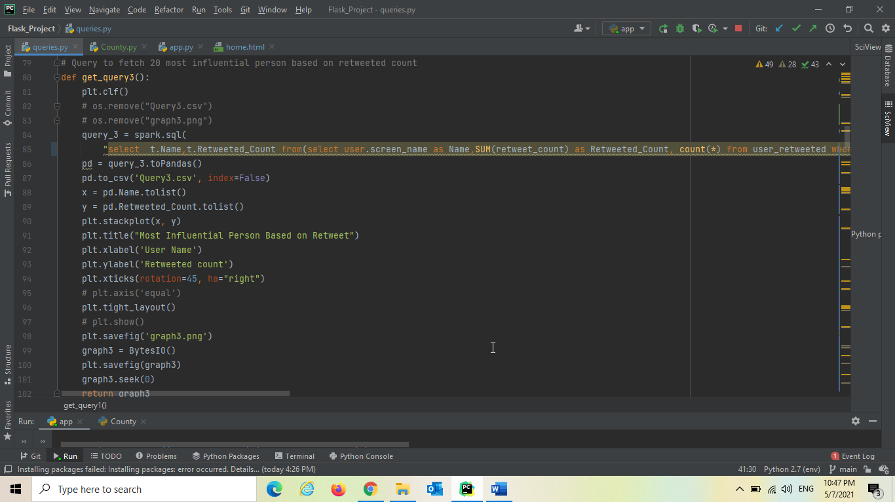

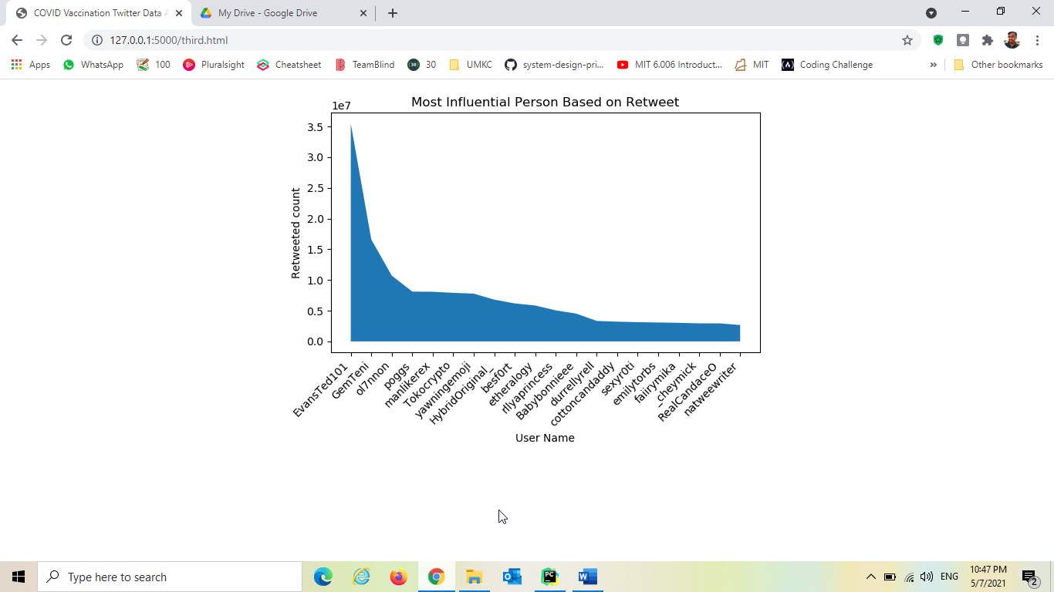

When user clicks on languages, it goes and triggers the query “Top Languages Used in Profile” and dynamically generates visualization and returned to the application

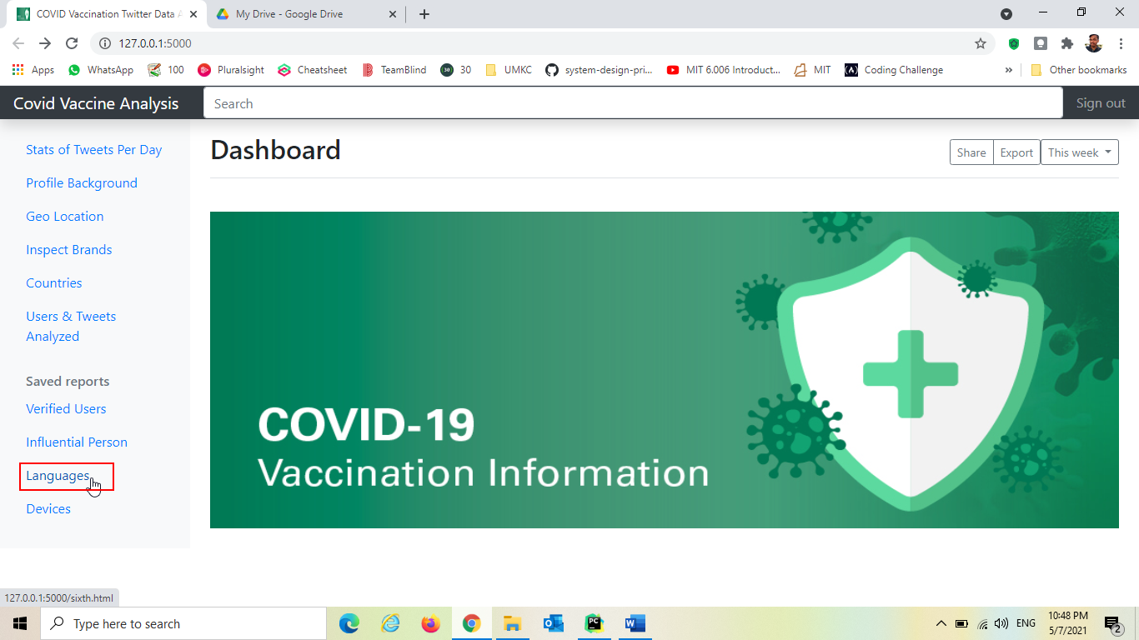

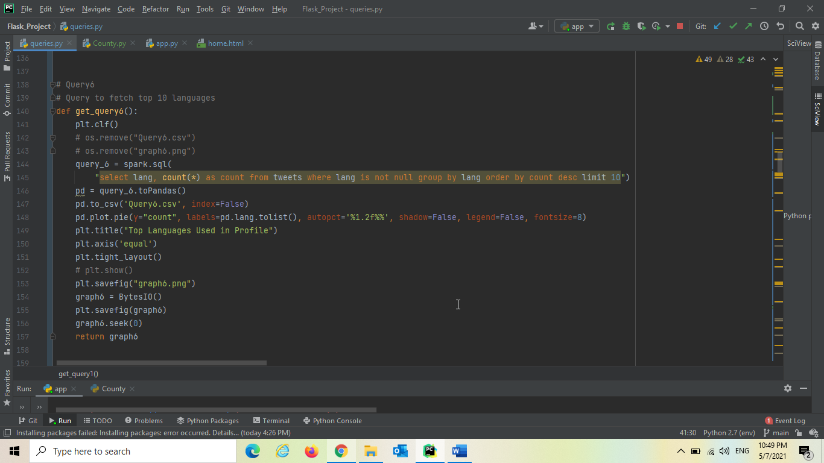

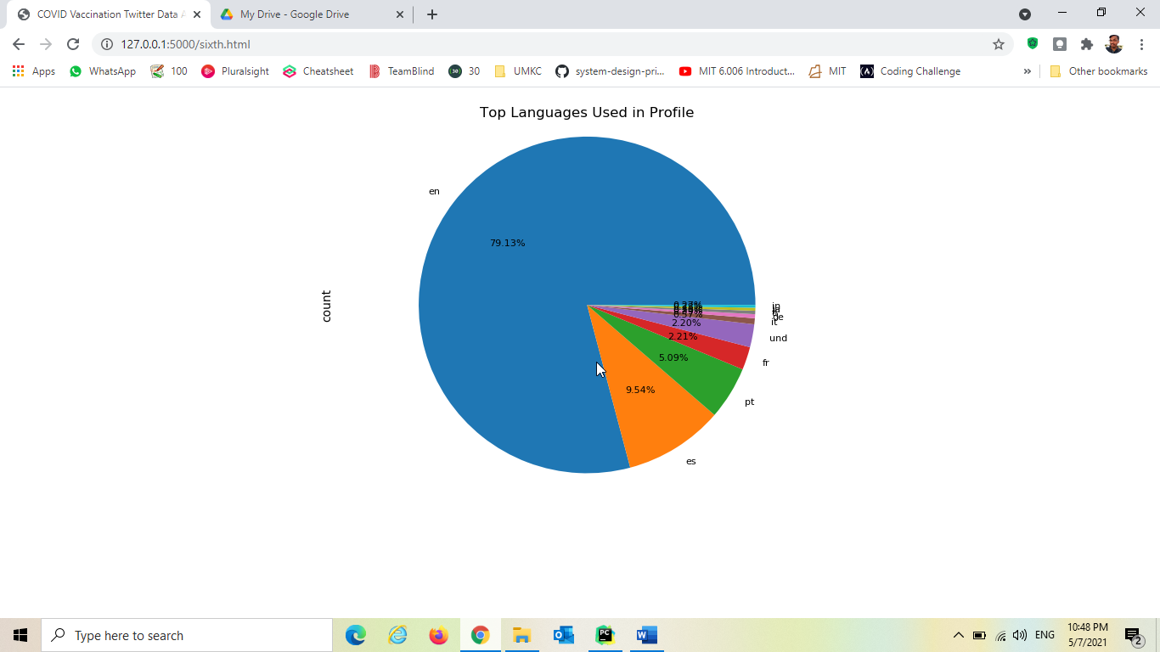

When user clicks on Devices, it goes and triggers the query “Devices Used for Tweets” and dynamically generates visualization and returned to the application

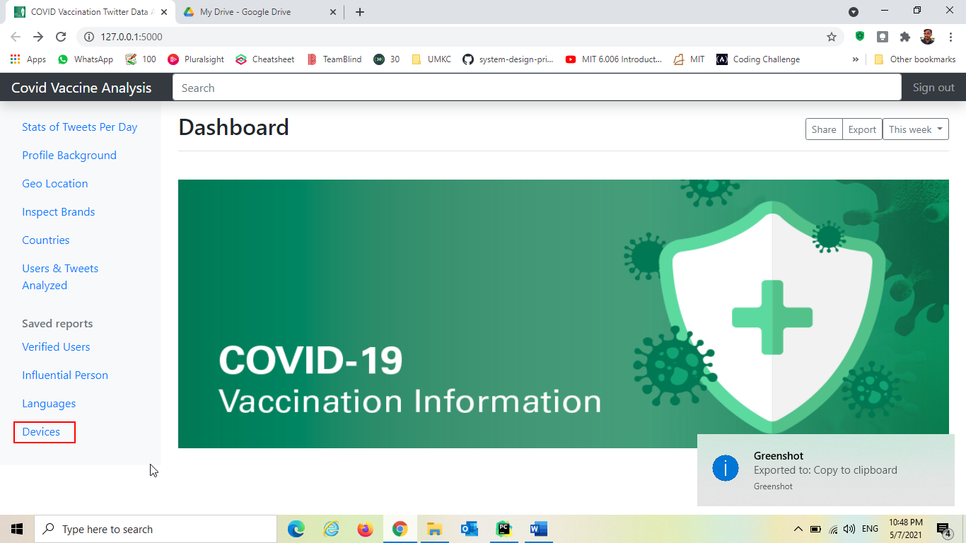

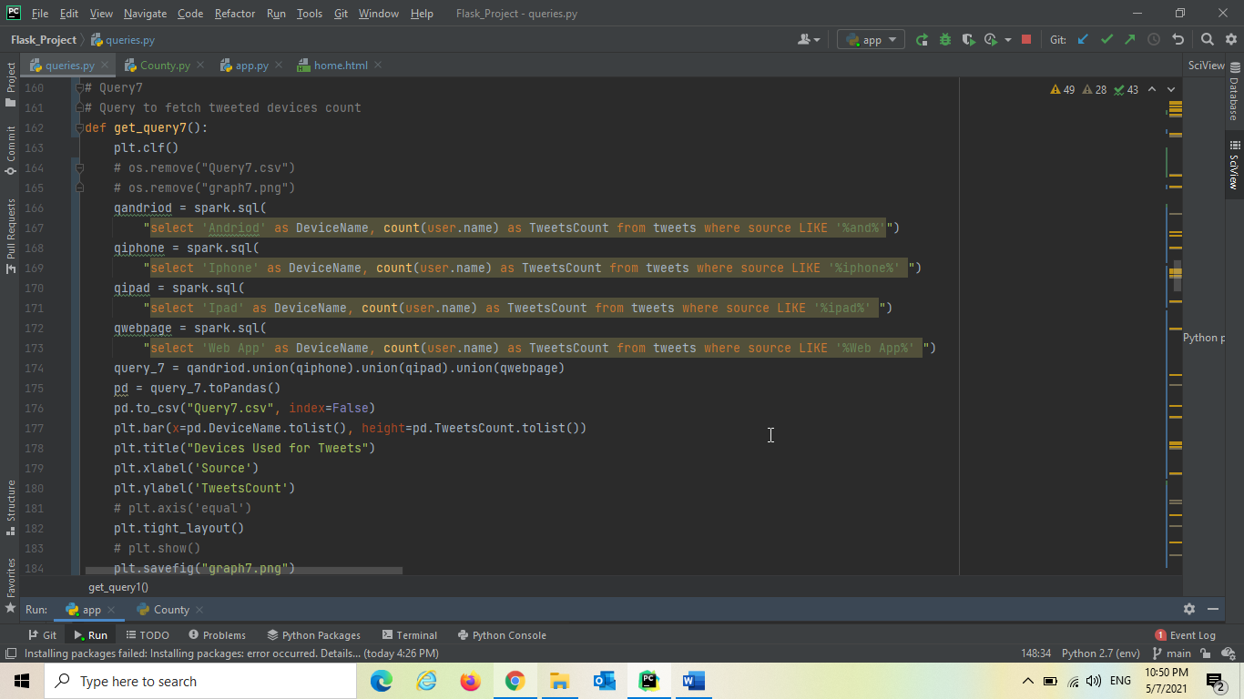

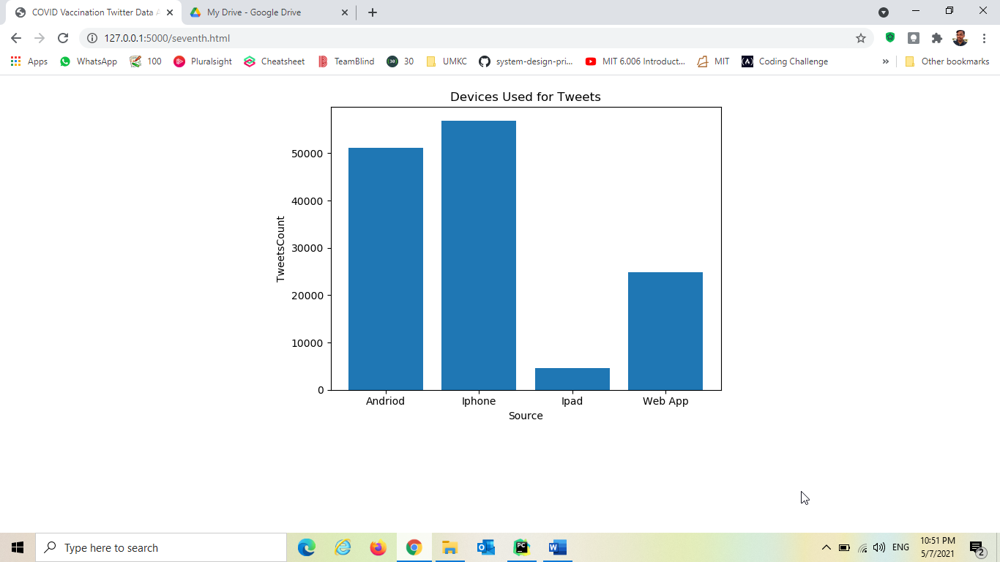

When user clicks on Stats of Tweets Per Day, it goes and triggers the query “Stats of Tweets Per Day” and dynamically generates visualization and returned to the application

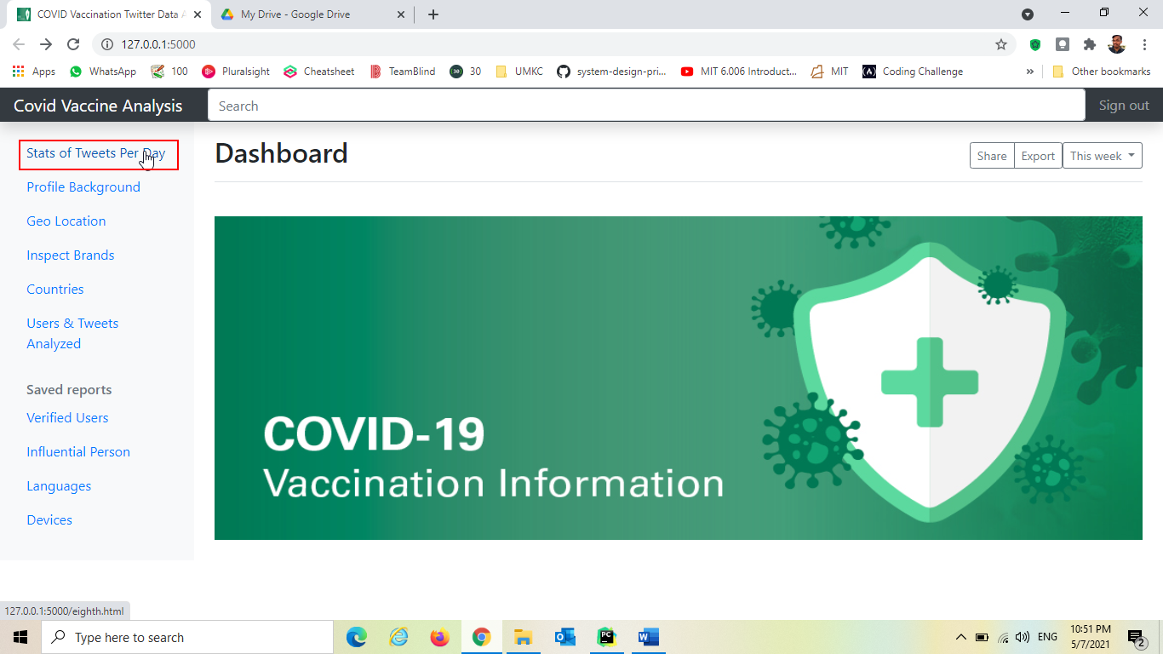

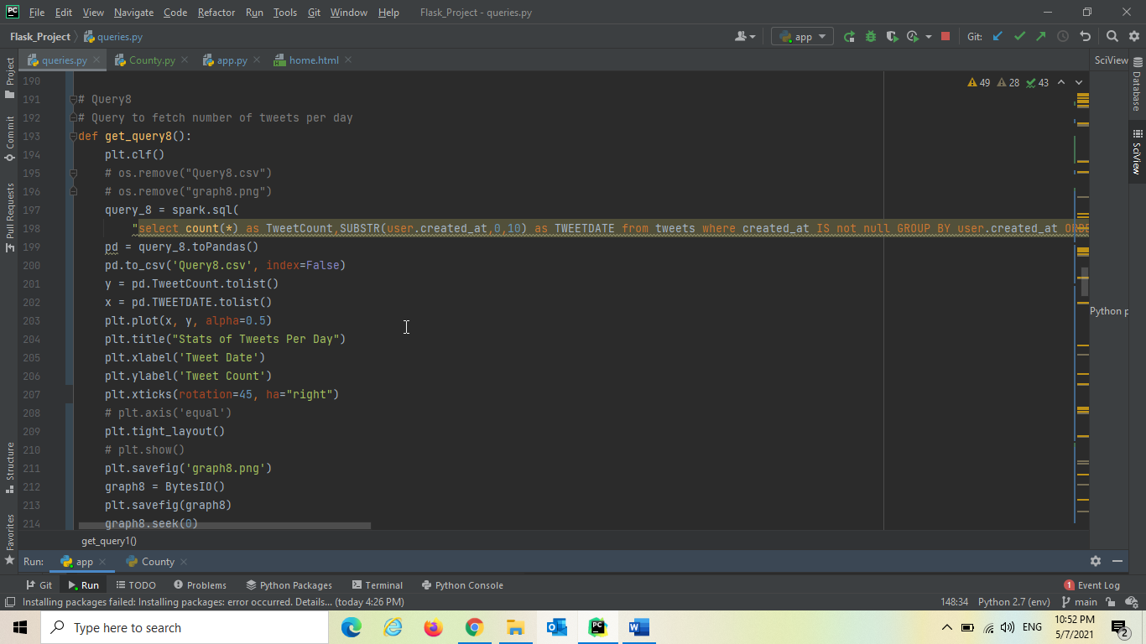

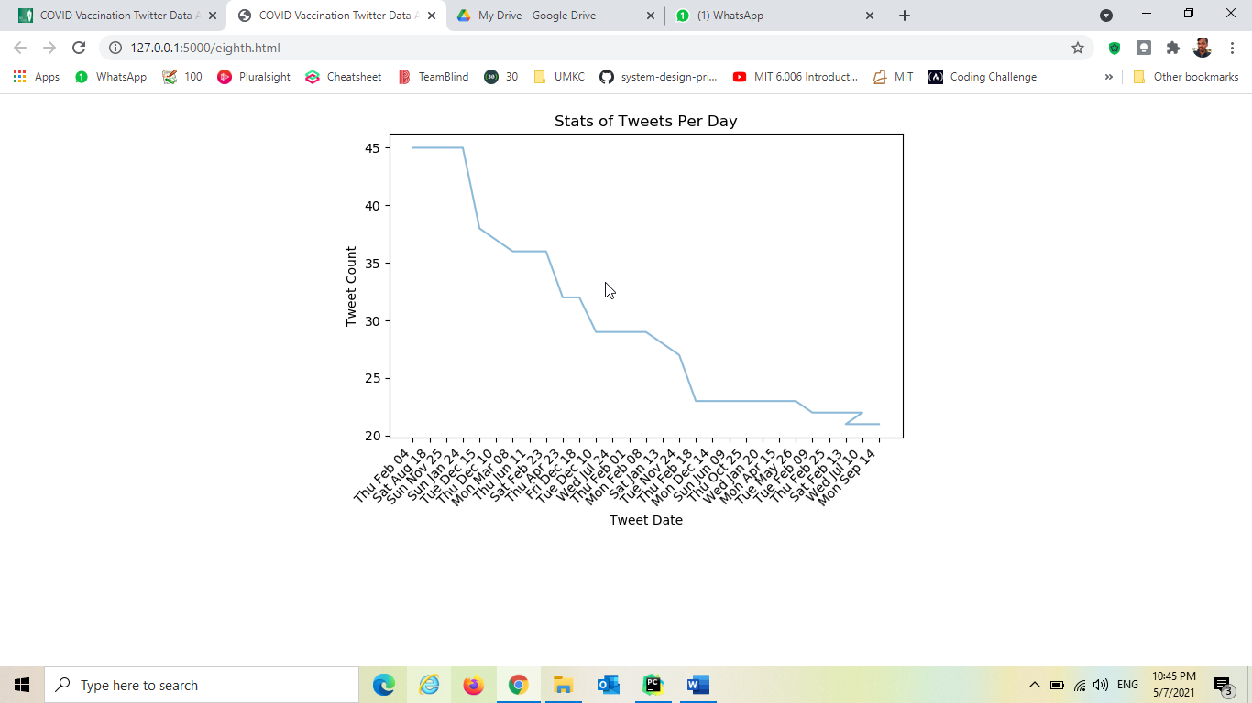

When user clicks User's Profile Background, it goes and triggers the query “User's Profile Background” and dynamically generates visualization and returned to the application

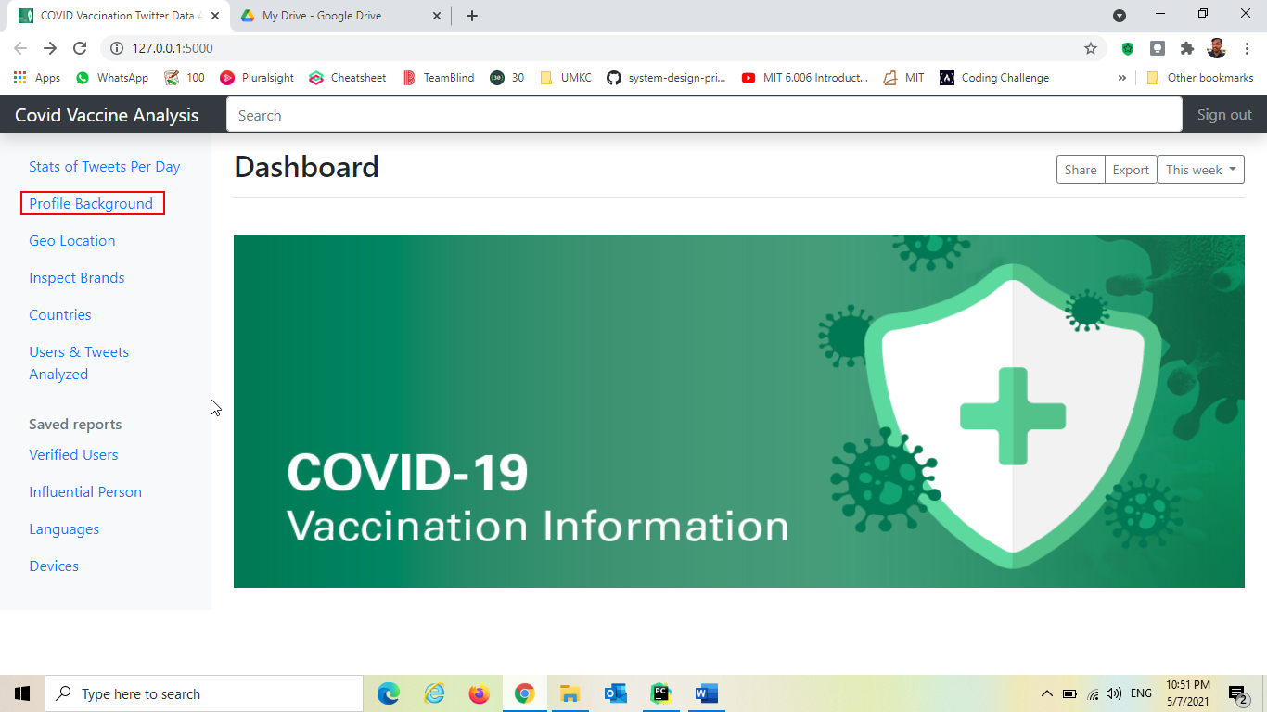

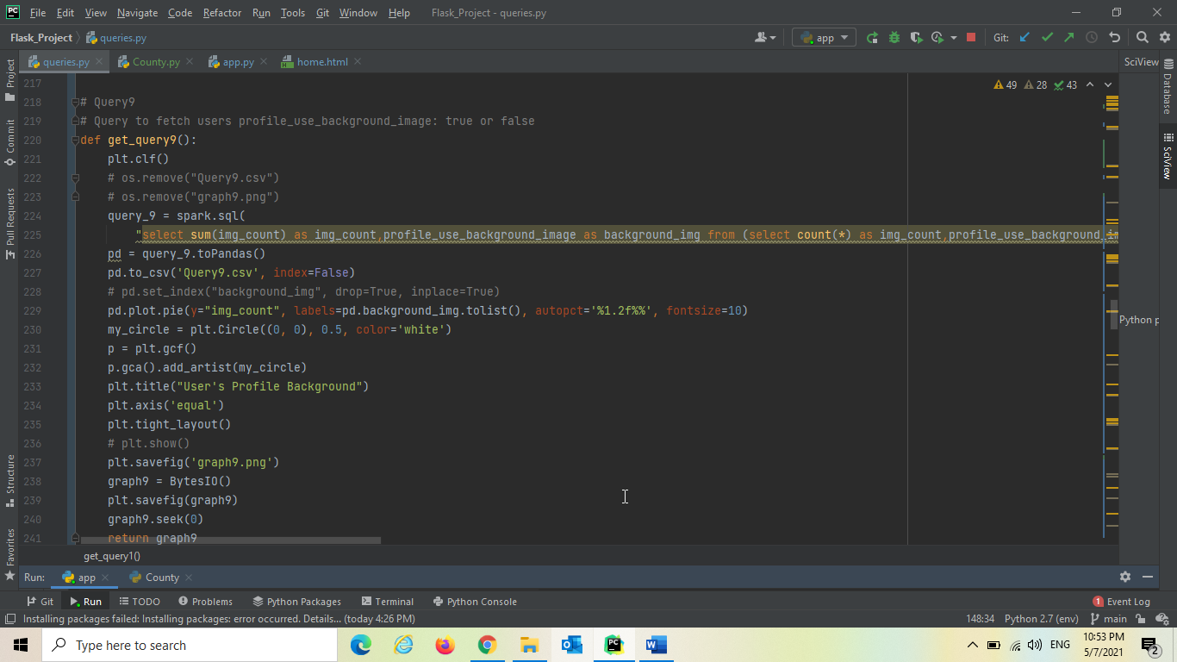

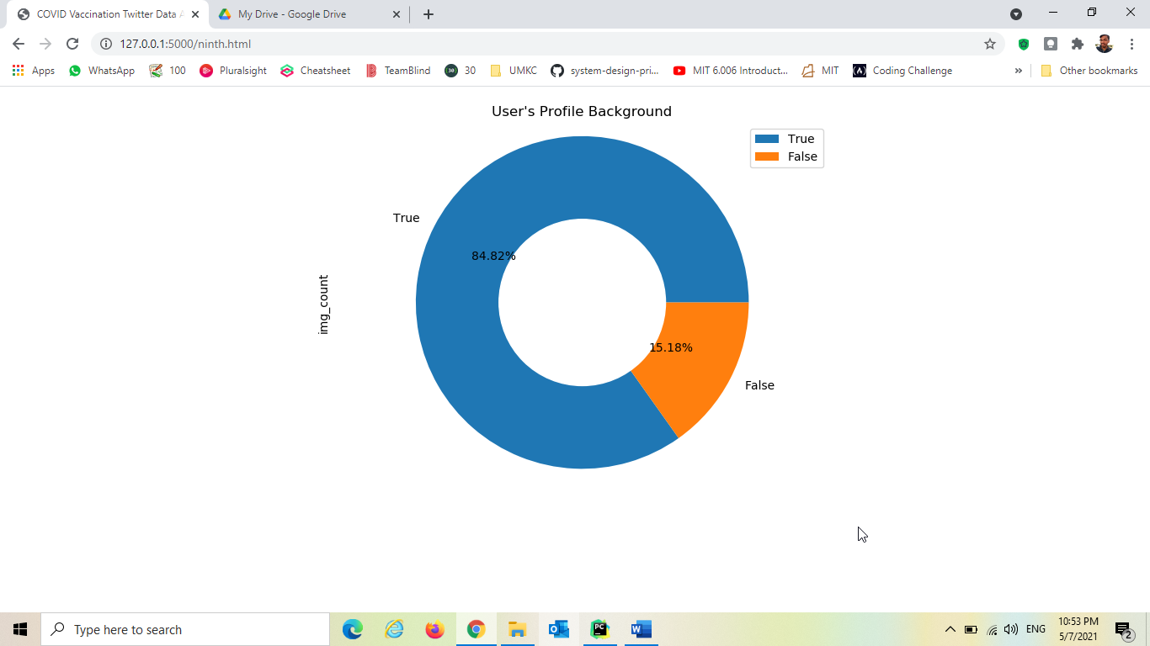

When user clicks Geo Location, it goes and triggers the query “Geo Location Settings Enabled for

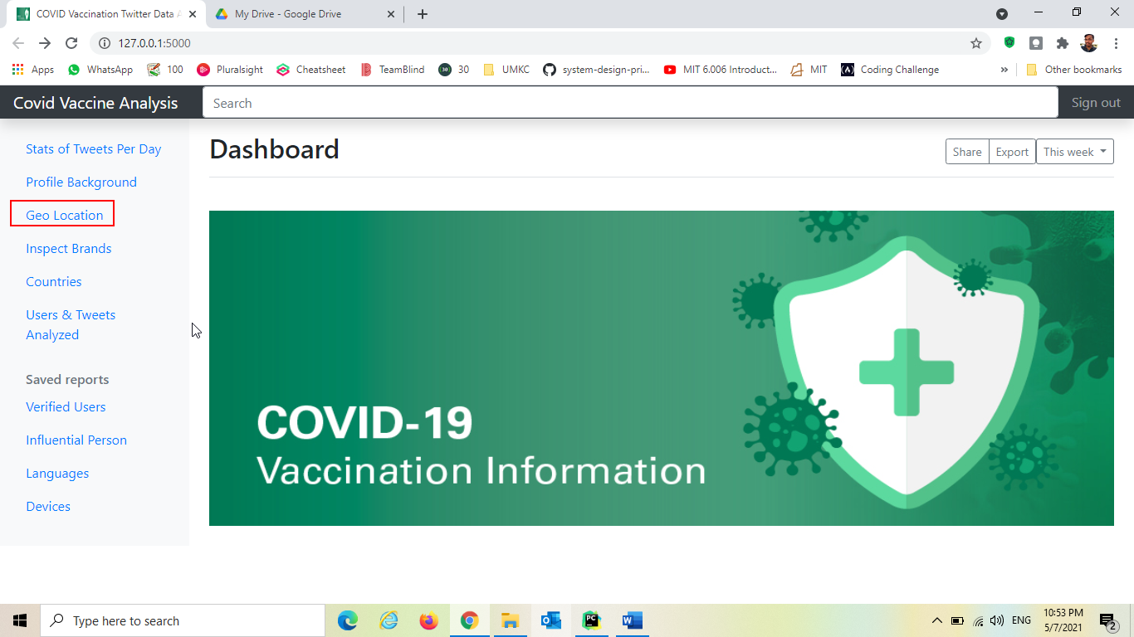

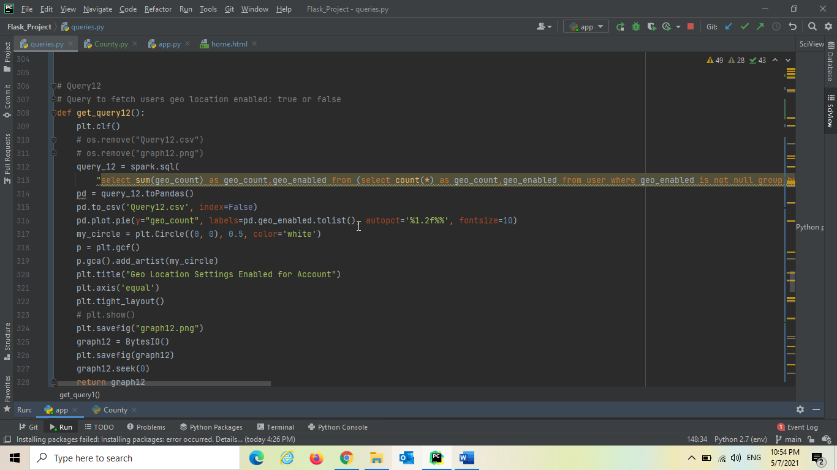

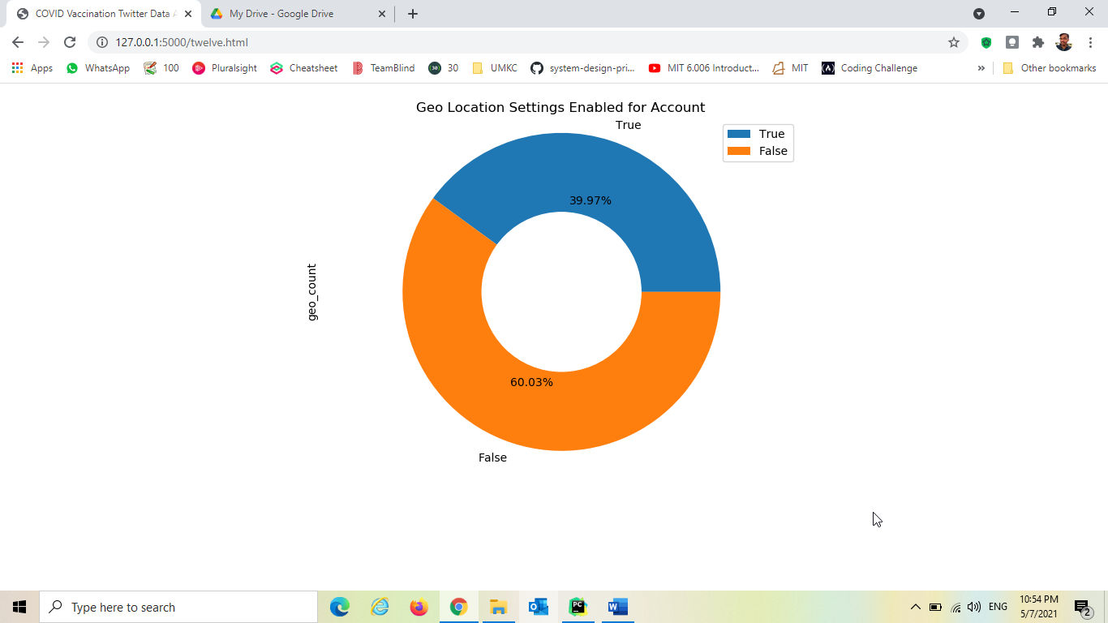

When user clicks Inspect brands, it goes and triggers the query “Inspect Based on brand” and dynamically generates visualization and returned to the application

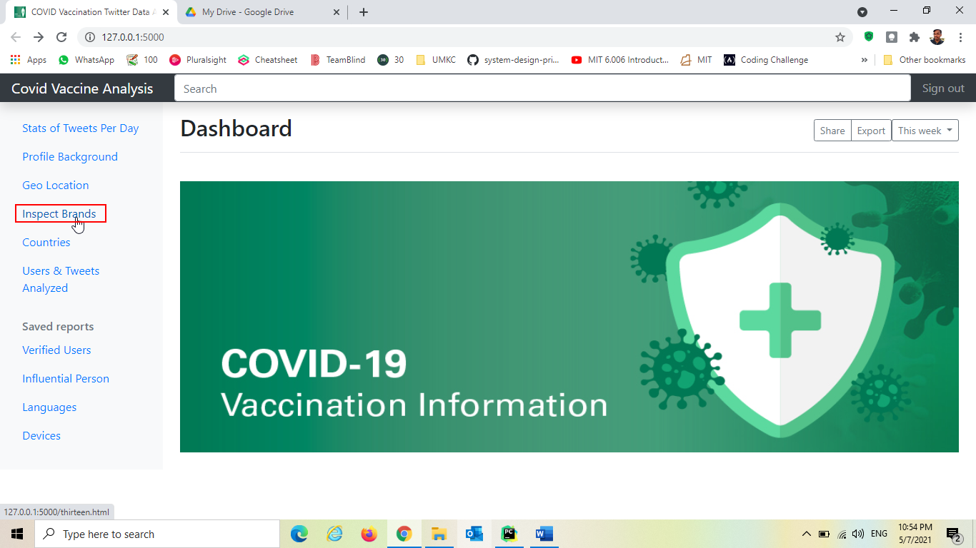

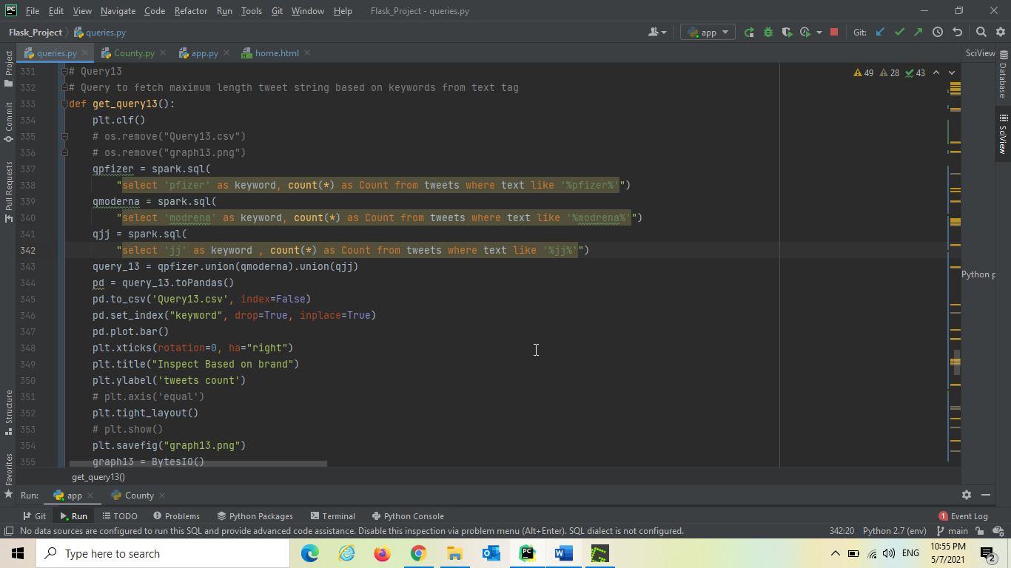

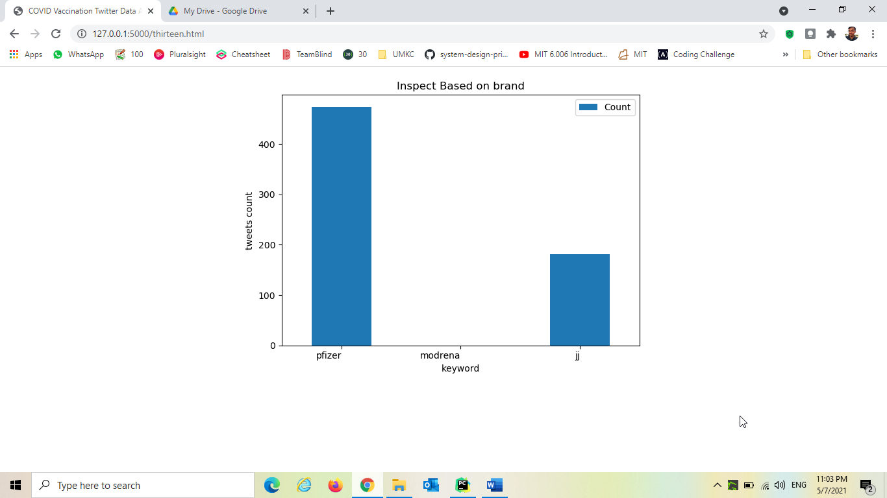

When user clicks Countries, it goes and triggers the query “Twitter Most Used Countries” and dynamically generates visualization and returned to the application

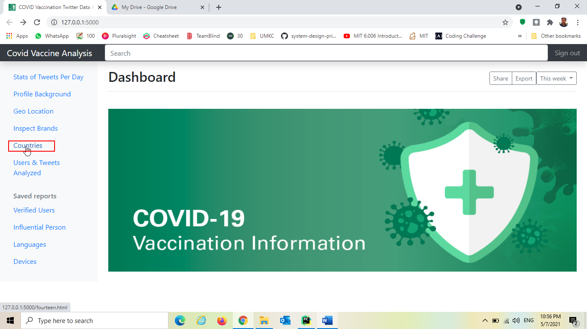

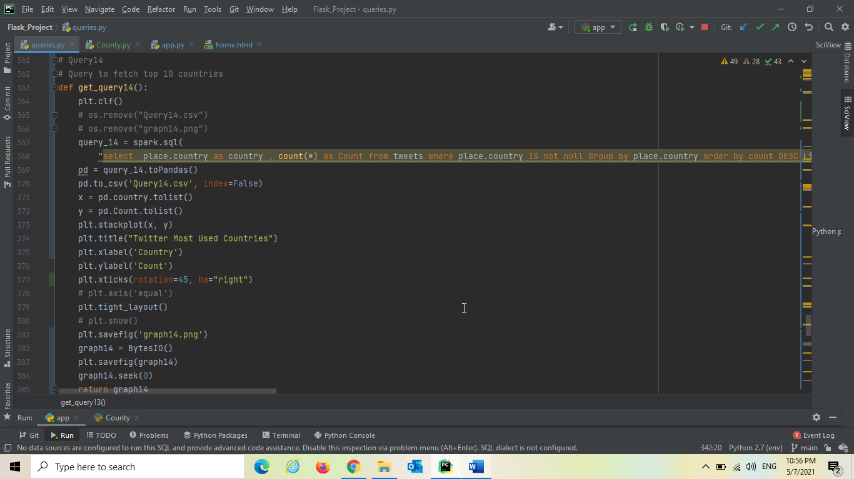

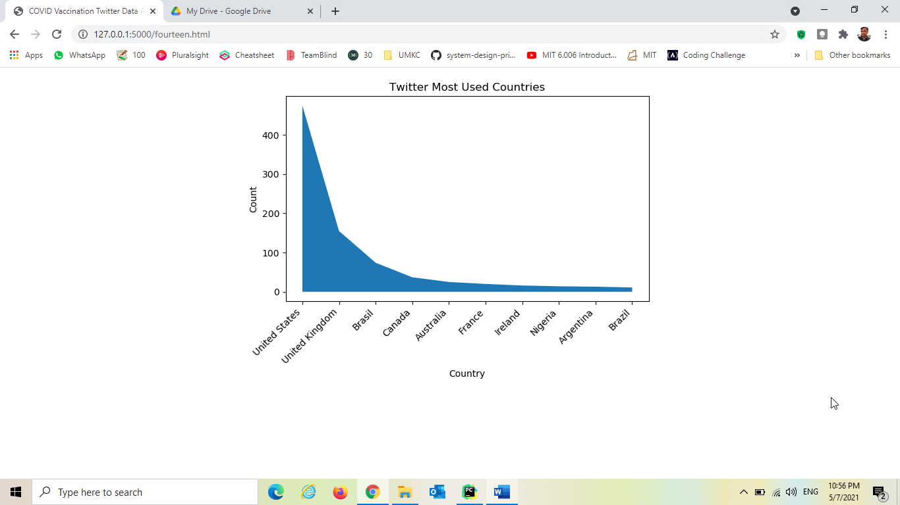

When user clicks Users & Tweets Analyzed, it goes and triggers the query “Users & Tweets Analyzed for Processing” and dynamically generates visualization and returned to the application

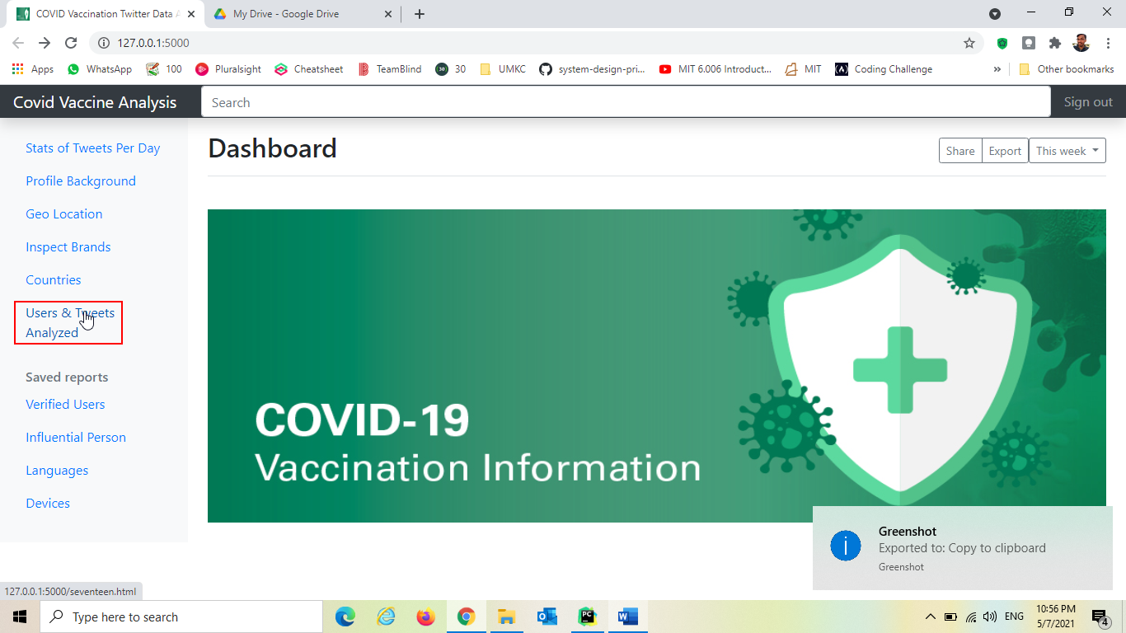

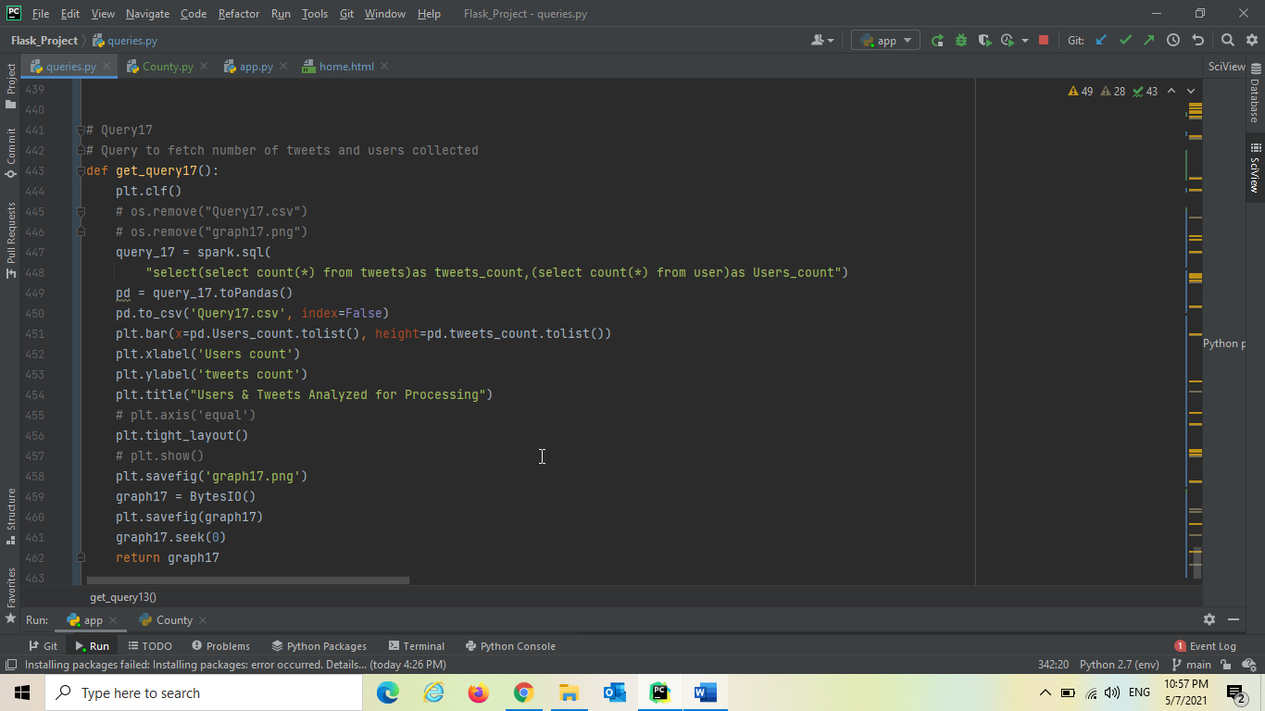

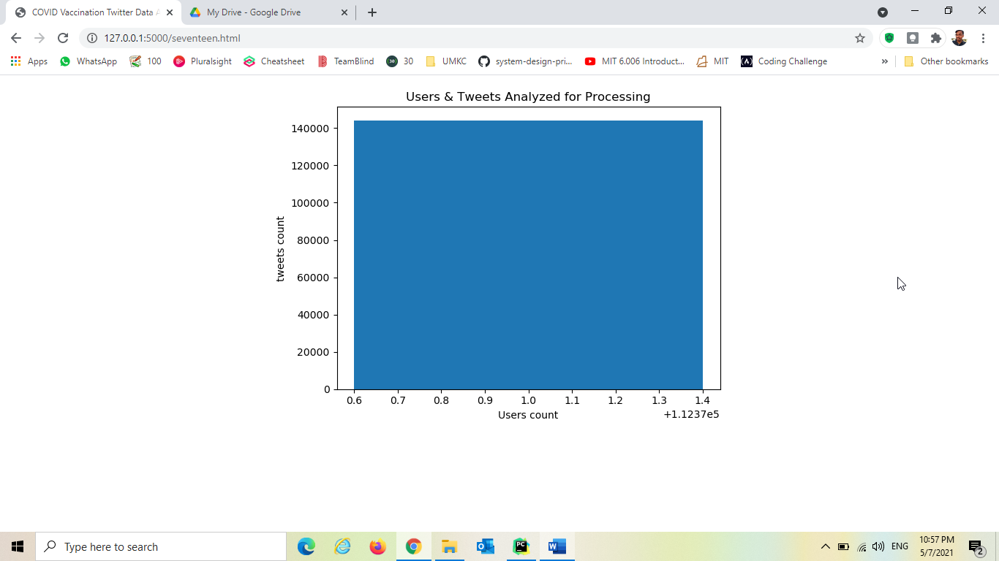

**Operations in Hive and their Results**

Starting Hive :

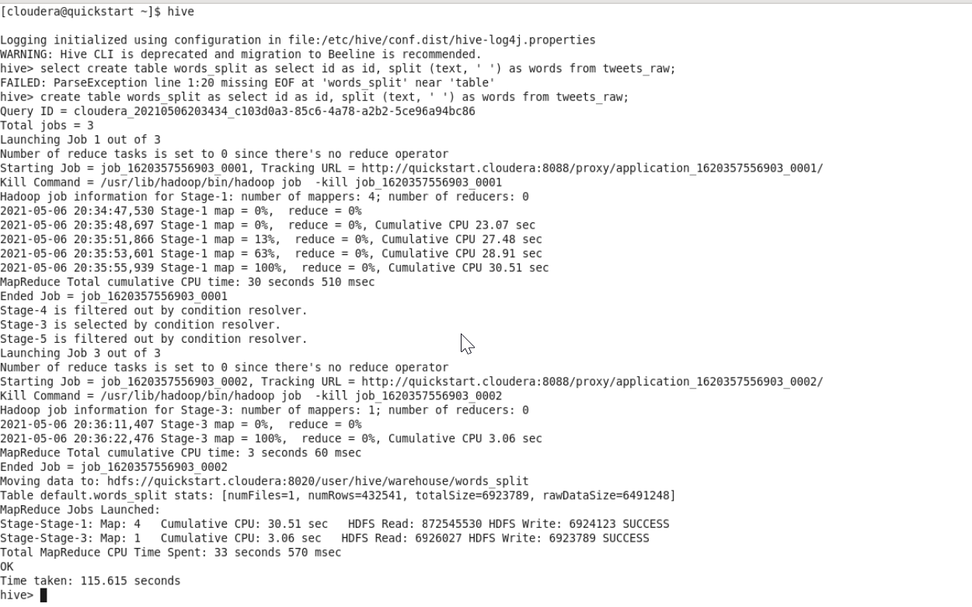

Describing data :

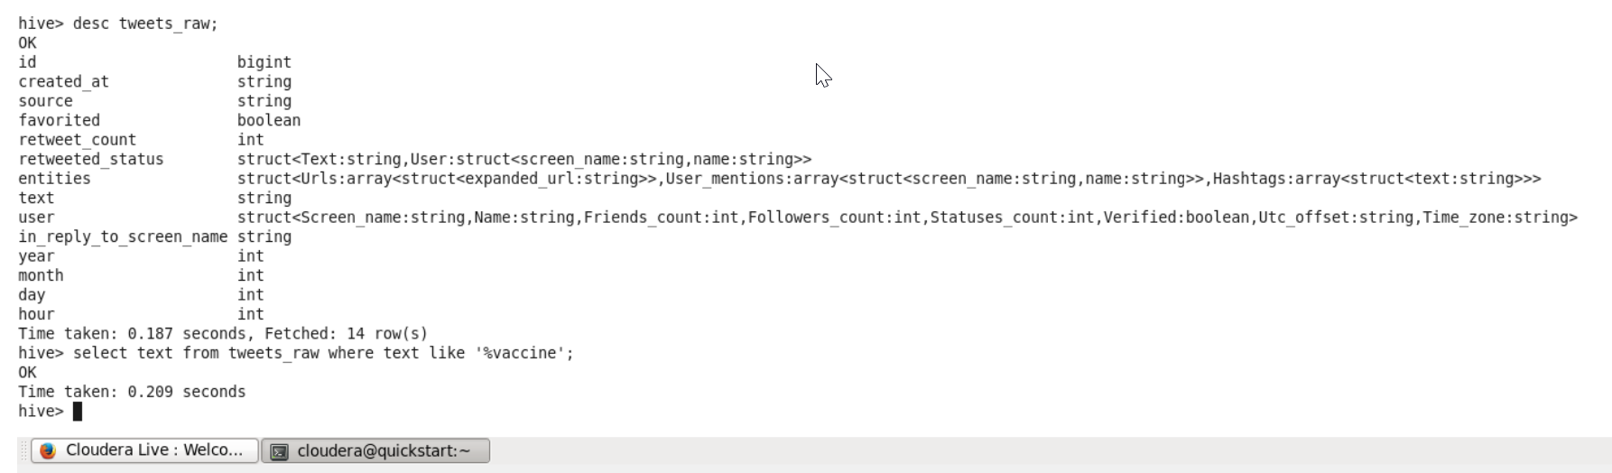

Data count in table :

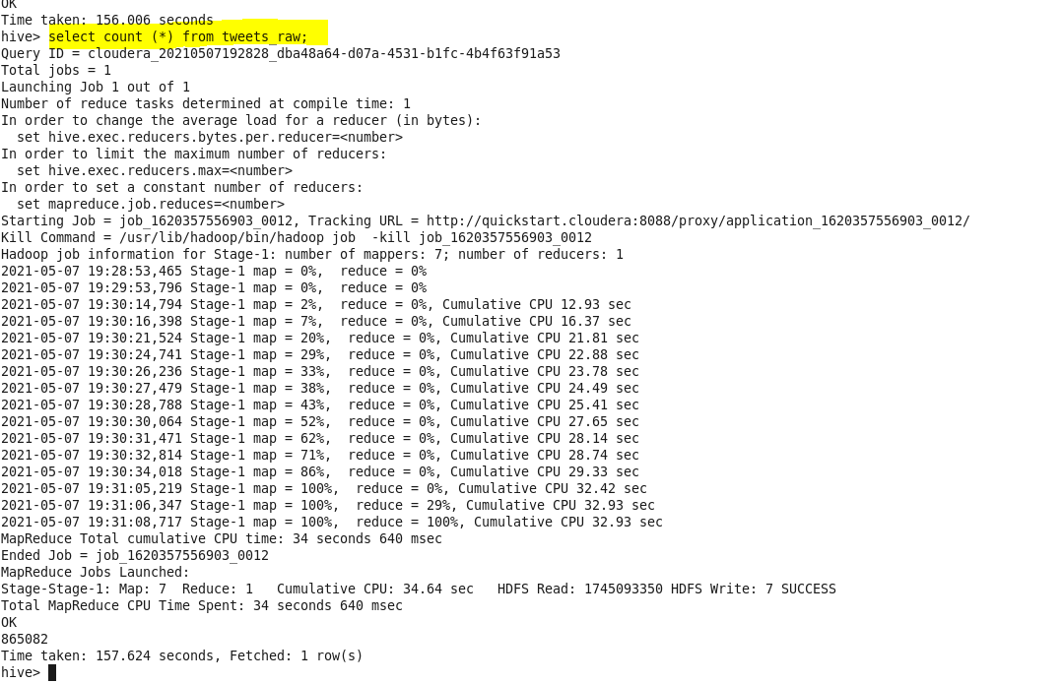

Fetch the first row data in the table



Count for number of persons retweeted

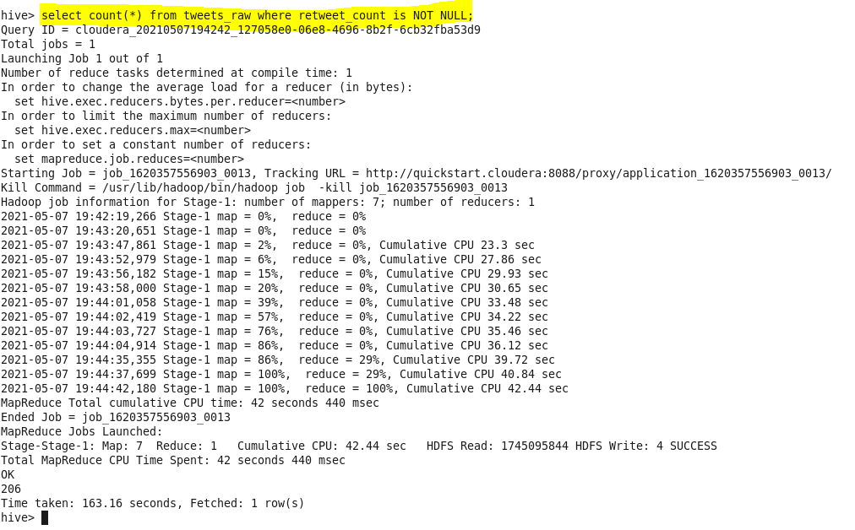

List of Id’s Retweeted :

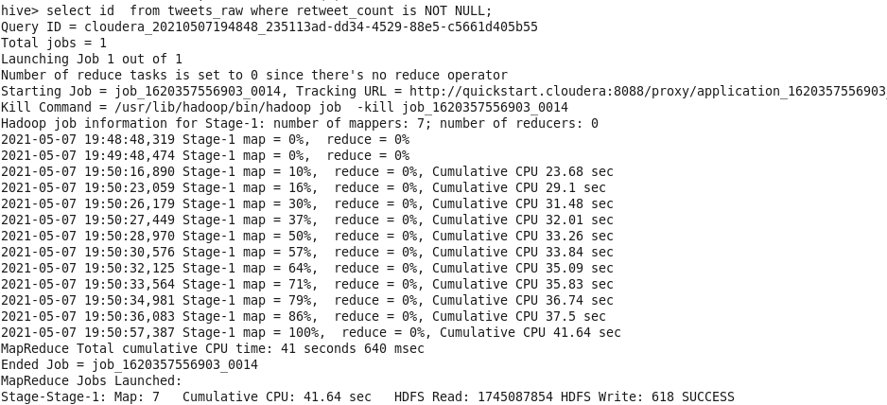

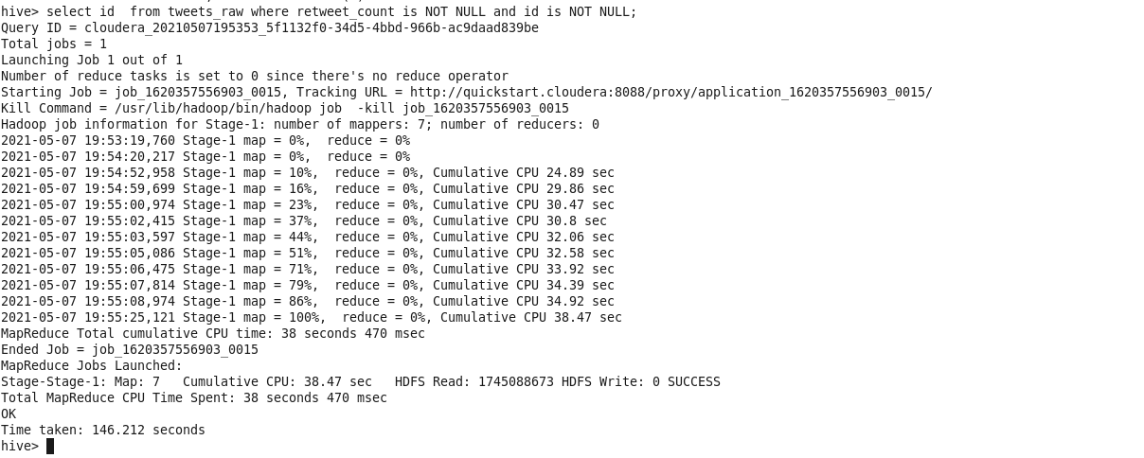

Finding out Keyword COVID :

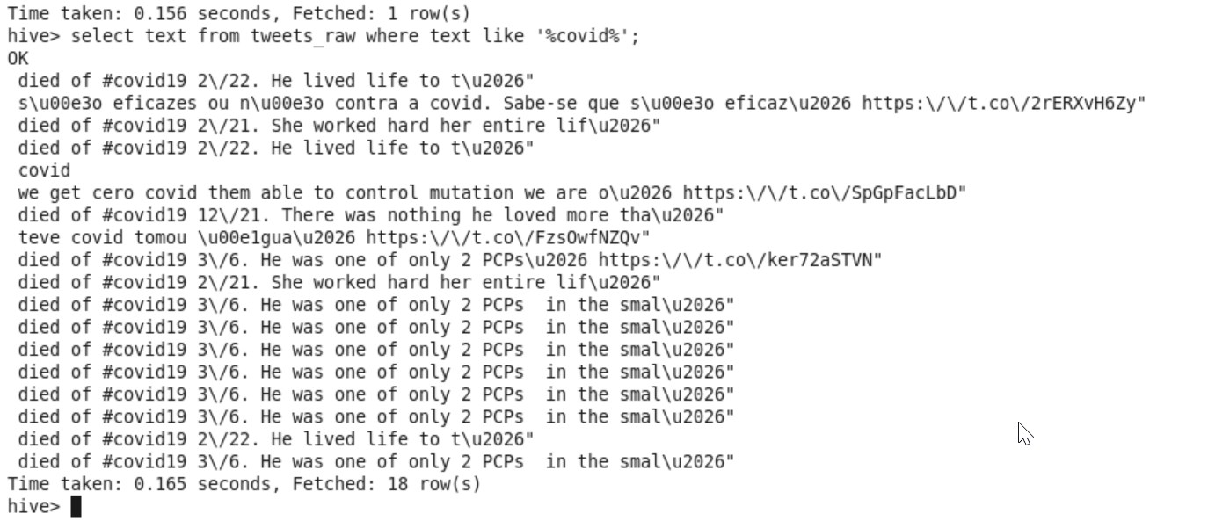

In the year 2019:

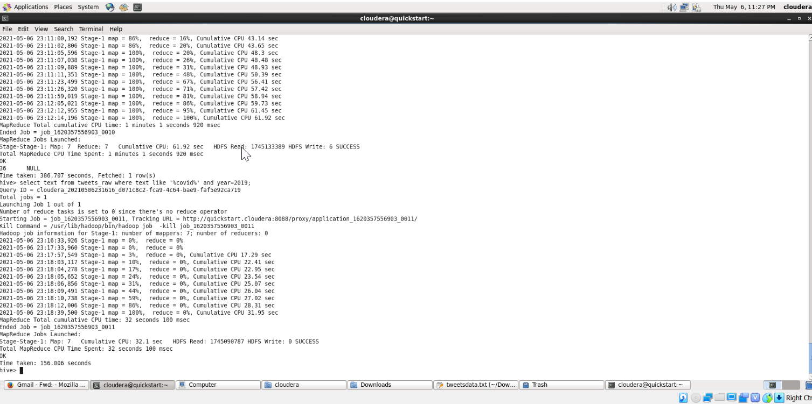

December Month Analysis :

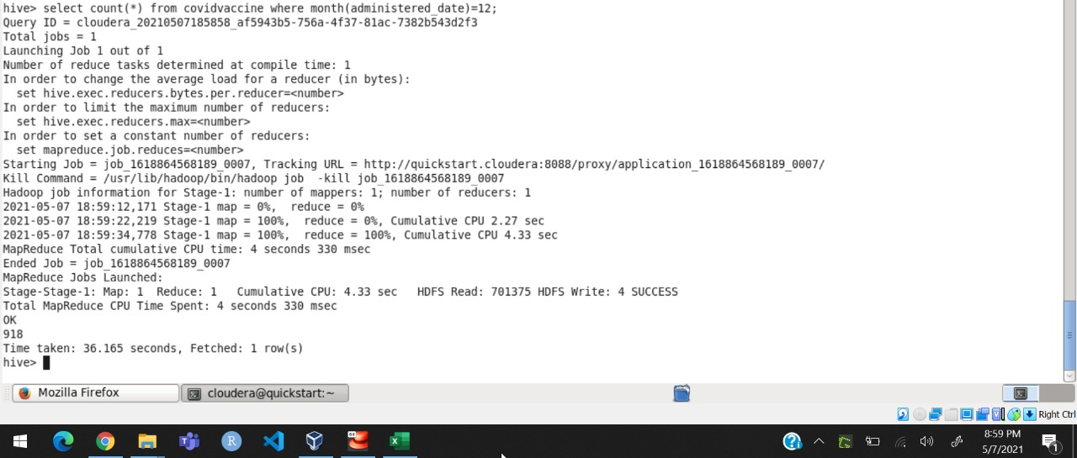

Jan Month Analysis:

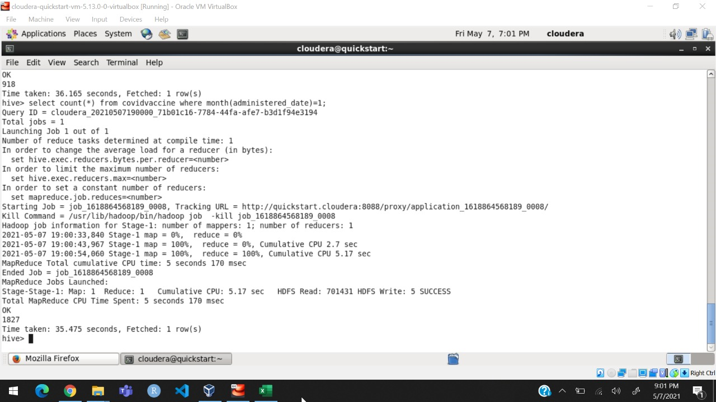

Alameda county analysis in march month

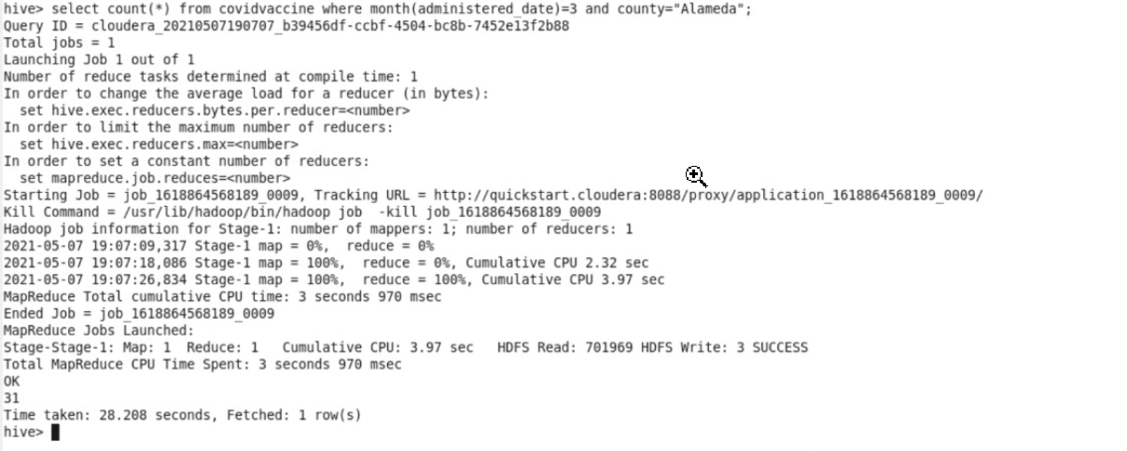

Counties that are fully vaccinated :

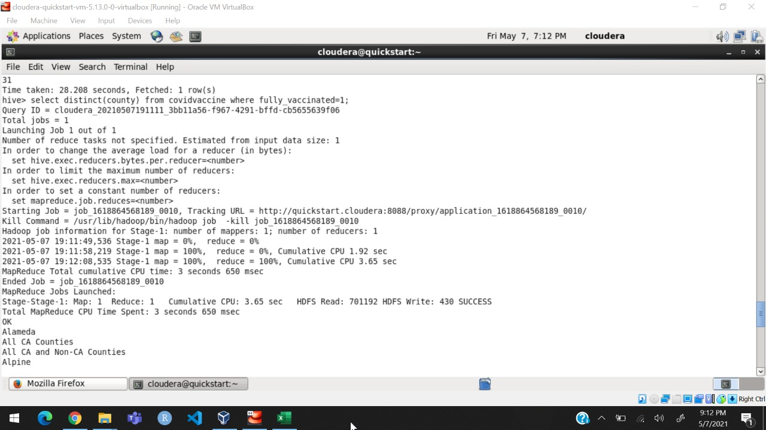

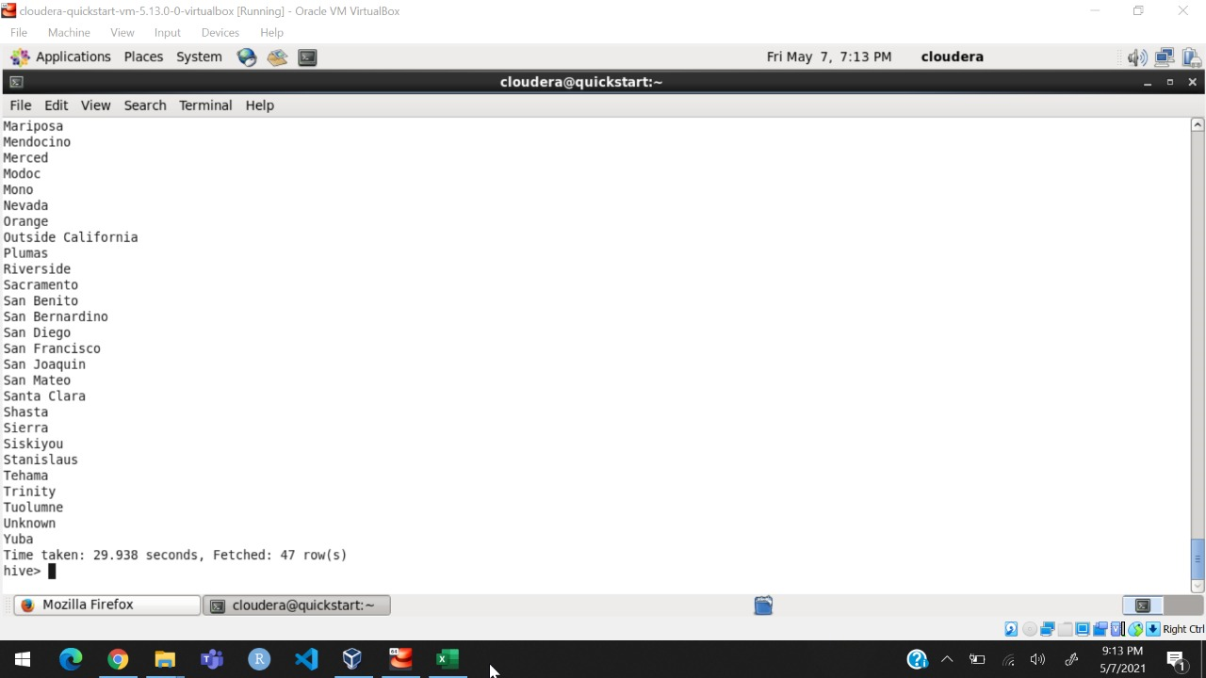

Number of doses change for December month in Alameda county (Every day analysis)

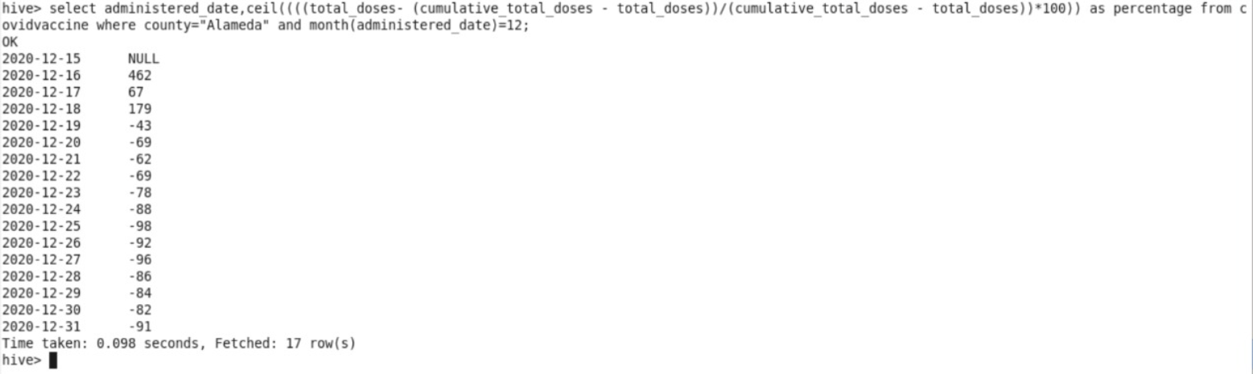

**Operation in solr:**

**Schema :**

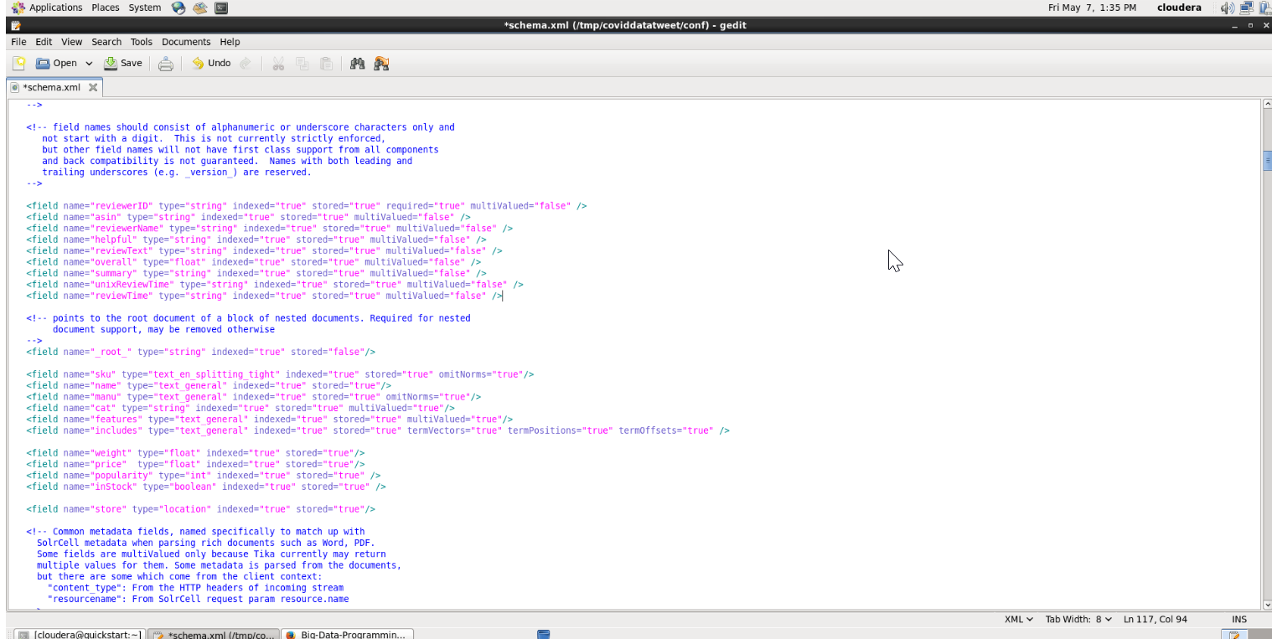

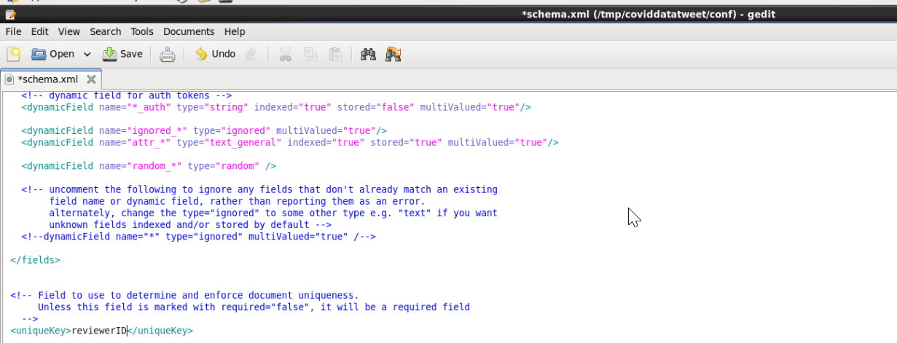

Creation of instance:

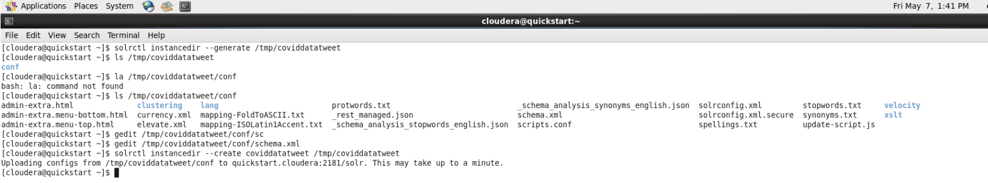

Creation of collection:

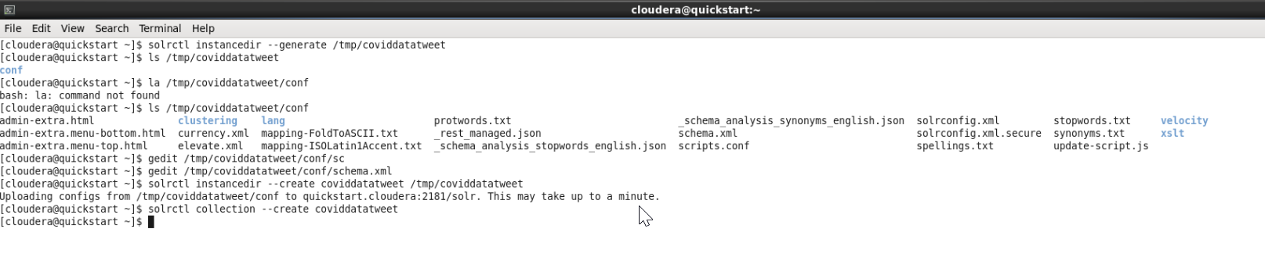

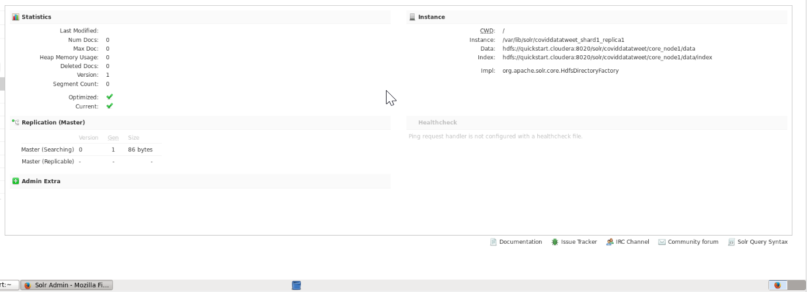

**Conclusion** :

With the aid of the Hadoop ecosystem, we were able to successfully analyze data extracted from twitter social opinions based on vaccination using this method. After analyzing the above data, we can obtain a pattern that can be used to forecast movement in vaccine such as Pfizer, Moderna, and J&J. This could be useful to the public and the government in the future when it comes to vaccination information.

These developments can provide early signs to the government as well as people, which could assist in getting everybody vaccinated. As a result, we can conclude that this method helped us achieve our target. Work in the future We just looked at the Twitter API, from which we extracted from Twitter using keywords like COVID, PFIZER, MODERNA etc... We will expand this range of extraction on keywords and time frames in the future if necessary.

**Project Management**

**• Work completed**:

1. Extracted tweets using python script and twitter API for the dataset.

2. Loading the data into the HDFS.

3. Analysis done on every tweet in the dataset.

4. Wordcount on hashtags using mapreduce.

5. Creation of table and loading of data into Hive.

6. Analysis of data using Hive

7. Visualization using Matplotlib, seaborn Packages .

8. Initialization and loading the data into Apache Spark.

9. Analysis of data using SparkSQL

10. Technical analysis by comparing Apache Spark, Mapreduce and Hive

• **Contribution:**

Prakhya Srungarapu : 25%

Worked on Extracting tweets using Python. Done sentimental analysis using AFINN dictionary which gives polarity value. Extracted tweets were stored in HDFS. Created and loaded data to hive. Performed few queries in Hive.. Contributed in drawing the comparison between trends of system and real.

Shiva Kumar Murarishetti : 25%

Worked on Apache Spark, helped in doing analysis on every tweet in the dataset. Drawn the comparison between Apache Spark and Mapreduce. Done wordcount on extracted hashtags using MapReduce. Contributed in analysing the data in Hive. Performed all tasks in Spark. Analyzed the data using Spark SQL. Have done few Visualizations.

Sai Saranya Vipparla : 25%

Done hdfs operations on the extracted dataset. Performed few queries on the dataset using hive and Cassandra. Drawn the comparison between Spark and Hive.

Vamshi Kumar Routhu : 25%

Performed all tasks in Apache solr, Wrote the schema of the project. Part of Visualization work.

**Story Telling: Chapter-1**

**Who are the people or communities in need of help?**

Since the beginning of vaccine delivery in the United States on December 14, more than 68 million doses have been distributed, totaling 13.9 million. Government and public health departments will use this to monitor vaccine progress using data and insights, helping them to increase the efficacy of their programs. This will help healthcare providers streamline their vaccine processes.

**What problem happened to them?**

Having improper data of the COVID vaccination would hinder the process of improving the vaccine's efficiency, knowing the total vaccinations given out with their trail-based success rate would help to further improve it.

**When did the problem take place?**

COVID-19 vaccination is very much important to help stop the pandemic. In real time, knowing how many people have taken the vaccine around the globe helps us to get an analysis of how well the vaccine is being received by the people and to know the distribution structure of the vaccine.

**Where means two things: 1)The environment and settings that the people or the community is living in, and 2)the place/location where the problem take place.**

As Covid is a global problem this would be effective and helpful for most sectors but mostly would be beneficial for the health and research departments which are looking to develop immunization for various new diseases and infections.

**Why means the possible causes and/or origin of the problem.**

Following the isolation of a coronavirus in December 2019, its genetic sequence was released on January 11, 2020, prompting an immediate international response to plan for an outbreak and accelerate the production of a COVID-19 vaccine. Right now, orchestrating the delivery of billions of vaccine doses is the greatest problem the world faces. In ensuring that it is achieved safely, efficiently, and equitably, technology will play a critical role. Tracking the vaccination progress will help in analyzing the number of people vaccinated and how many new vaccines needs to be developed.

**How did it happen? Sometimes, the answer to how can be covered by what, when and where.**

People understandably have a lot of questions about the new vaccines, particularly because vaccines are being developed at an alarming pace and the virus is still revealing its secrets. Health experts stress the importance of vaccinating as many individuals as possible to avoid the outbreak, as global COVID-19 cases exceed 100 million. The more circulating virus indicates the greater risk of mutations, and some recent strains tend to be more infectious already, making vaccination even more of a race against time**.**

**Story Telling: Chapter 2**

**Who is the data set about? Who were sampled in this data set? Who were over sampled or under sampled?**

The data is about Twitter public data i.e; The dataset is about the clients who tweeted with the watchword "VACCINE” (for this situation) in the twitter. There are numerous quantities of clients who tweets in twitter. Accordingly, it help us in investigating more information. This dataset contains just open accessible data.

**What events, activities, behaviors, and observations etc. are recorded by the data set?**

The dataset contains the tweets extricated from the twitter which contains client data, tweet text, hashtags, made time and their substance data. These are the significant factors utilized in the task.

**When did the event, activity, behavior, and observation, etc. take place? When were the data collected?**

The information is created when the client tweets about Covid Vaccine in the twitter. There will be a more prominent number of clients who tweets same. The information in out dataset comprises of all the tweets which contains COVID and VACCINE catchphrase. As the twitter data is live we have taken the old data(like previous months data).

**Where did the event, activity, behavior, and observation, etc. take place?**

The dataset consists of tweets which are extracted from twitter. Twitter consists of huge amount of data. It is an online social media platform. It has more number of users. This data set contains geographical information of the tweeted location. This dataset doesn’t have geographical limitations

**Why did the event, activity, behavior, or observation etc. take place? Why were the data collected?**

Data is collected In order to sort out the vaccinations that were being supplied to counties and to get the count of vaccination.

• Calibration 1: Every aspect covered in Assignment 1 aligns with the Assignment 2. We have choose right dataset in Assignment 2 for analysis as mentioned in the Assignment 1. And, this is the relevant dataset to the project.

**Story Telling : Chapter 3**

• Calibration 2: Experimented different models for our system using various techniques. Aligned the data according to the process of using all kinds of techniques. Applied accurately on the unstructured data from twitter dataset.

**Who: In this story, there are three main characters: 1) the people/the community who needs help, 2) the data scientist (that is you), and 3) AI. How much does the data scientist understand Assignment1 (domain) and Assignment2 (data)?**

The domain chapter will be understood by the student/data scientist because it will resemble the whole concept of the project that needs to be completed and can also be considered specifications technically. Later stages of the project would necessitate domain awareness. In addition, once the data scientist has obtained domain-related information, he or she must work on the data to process and interpret it in accordance with the requirements.

**What models and analysis did the data scientist and AI apply to fulfill the need of the people or the community? Can the data scientist estimate and select data for their goals from Assignment1? Can they map data sets from Assignment2 onto appropriate ML models? Can the data scientist connect Story 1 with ML models/stories about what a ML model can do? To perform good ML research, what in-depth knowledge and experience with ML algorithms and ML stories does a data scientist need?**

The data scientist chooses the data based on the objectives set out in Chapter 1. Data scientists will collect data as stated in chapter 2's goals using the same data. The domain knowledge is then applied to the data. The data scientist in this project would need to be familiar with the Hadoop ecosystem.

**When has to do with the iterations (Calibration 2). How much time did it take for experimentation? How efficient is the modeling/algorithm? Can the data scientist determine the acceptance level of the model (validation with accuracy and runtime performance) considering the targeted users?**

This project made use of a variety of technologies. We will have different run time outputs and accuracies for each study performed using one technology in the Hadoop ecosystem. In this project, we only dealt with NLP techniques such as sentimental analysis and data analysis using Hadoop ecosystem technologies.

**Where has to do with the learning environment. Where did this experiential learning process take place? For example, it was part of an online Deep Learning course.**

It was part of the University of Missouri-Kansas City's Big Data Programming course, as well as a few online classes.

**How: If you would like, you can add a dimension of how. How did it happen? Sometimes, the answer to how can be covered by what, when and where.**

The data scientist may use data in the way that the research requires or based on the tool.

Nothing in this method is static; new data or data sources may be introduced as required for further review.

**Chapter 4: Users**

**Who: the main character is the targeted user or audience?**

Project is targeting the vaccination record

**What can the application do? What does the visualization show?**

The chart depicts the previous months study of vaccination data gathered from Twitter. It offers vaccination movement using social opinions and various resources in the Hadoop ecosystem.

**When can the user use the application/visualization?**

The government and people is user here. The patient gets helped with the data and visualizations.

**Where will the visualization and applications be deployed, for example, mobile phones, the web, or IoT devices?**

The visualization as of now is generated using matplotlib, Seaborn Packages in python the data retrieved after querying in spark.

**Why is the visualization or application useful to the user?**

Data visualizations make it easier for the human brain to comprehend both large and small

amounts of data, as well as detecting patterns, trends, and outliers in groups of data. Good data visualizations should give context to complex datasets in order to convey a simple andsuccinct message.

**How will the people/the community use this application or visualization to make changes?**

It can be used in analyzing or visualizing the whole data related to COVID-19.

**Chapter 5: The society**

**Who will be impacted? Who were sampled? Who were over sampled or under sampled? Who were the data scientists (yourself and your collaborators)?**

The People will get impacted using system. We have used the peoples live data on covid vaccines and these were sampled.

**What are the social and cultural impacts? What are the concerns about data privacy, security, and fairness?**

The poeple only get impacted as stated above. We are using the data which is available in public only. We are not dealing with any impacting privacy or security or fairness of data.

**• When will the social and cultural impacts take place? When should people be concerned about data privacy, security, and fairness?**

There will be no cultural or social impact on the population since the dataset doesn’t populate any personal or confidential information of the person. The fairness of the data needs to be evaluated from time to time.

**• Where will the social and cultural impacts take place? Where will data privacy, security, and fairness issues, like data breach, and evaluative bias, likely to happen?**

The group of scientists have collected the data from a social media platform named Twitter. This data is available globally and people all over the globe have access to this data, so the data have no issues or concerns related to privacy or security. The data we have collected using an API developed by Twitter itself, which guarantees the complete authenticity of the data.

**• Why are the social and cultural impacts important or consequential to the people and/or the community? Why should we be concerned about data privacy, security, and fairness issues?**

In the development of project model and its execution the data used is completely generic and available globally, so there aren’t any issues pertaining to data privacy or security of information, also the data doesn’t contain any medical id or personal information revealing the identity of the person.